Adding a new hire

You can use the isolved Onboarding feature to have the employee provide most of the information needed to add them to the software. If you want to enter the information manually, follow these instructions.

On the Employee Management menu, select Quick Hire.

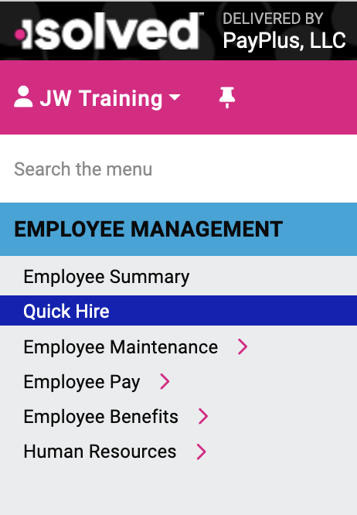

All the information about the employee is entered on this one screen: employee identification (name, address, SSN, DOB, marital status), pay information, taxes, direct deposit.

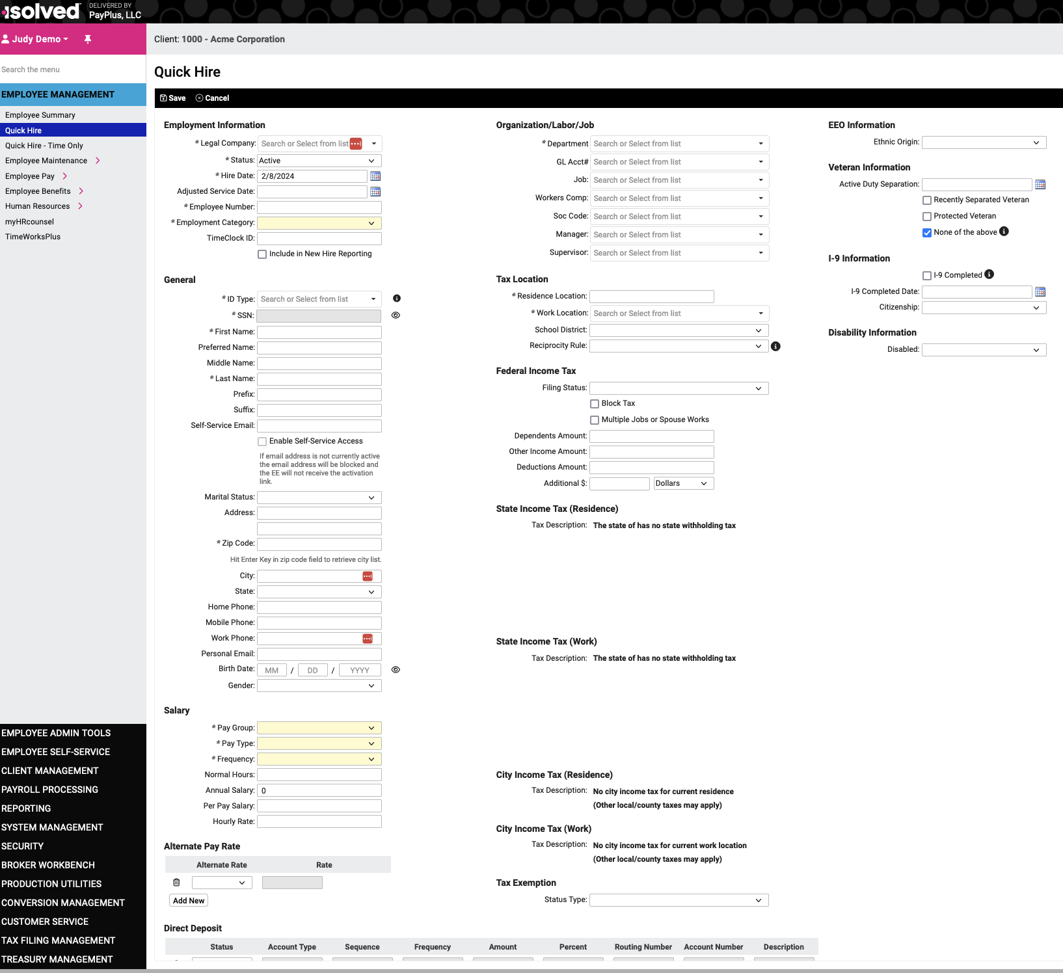

Here’s a video if you want step-by-step instructions and explanations of the options for each field:
https://learning.myisolved.com/library/quick-help-videos/adding-a-new-employee-using-quick-hire

