Adding or Changing Salary/Pay Rate

On the Employee Management menu, select Employee Pay and then Salary.

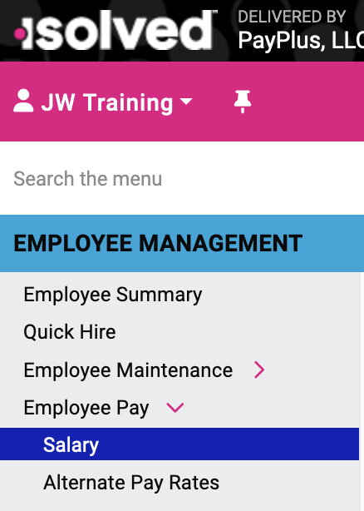

Select (double-click) the name of the employee whose pay you are changing.

Here you can see current and past salary information, calculate an employee’s rate increase based on a percentage, and add future rate changes.

To change the employee’s pay, select Add New. This will update historical records for the employee. Use the Edit button only to correct an error because edited items are not updated in the historical records.
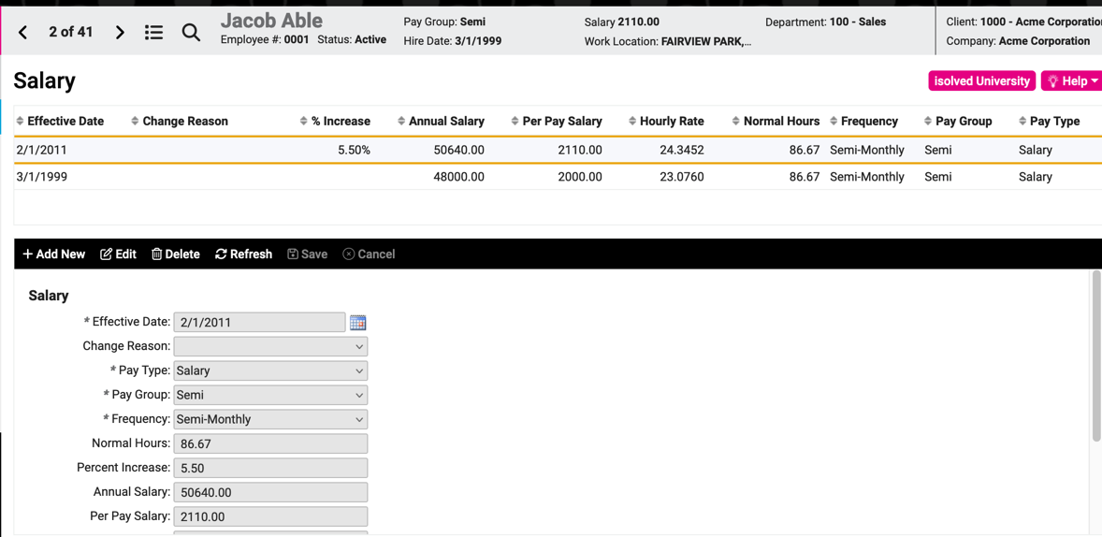

Video
https://learning.myisolved.com/library/quick-help-videos/adding-or-changing-salary-pay-rate
For detailed explanation of each field, see the isolved Quickhelp document Add or Change Salary.pdf

