Changing or withholding deductions
from an employee’s pay on an additional check

If you would like to withhold or change deductions on a second check being paid to an employee this pay period or for a bonus check, follow these instructions.

If you want these deductions to take effect for future payrolls, you will need to change the Employee’s record (Employee Management->Employee Benefits->Benefits) or submit a change form to your Payroll Specialist.

First, you need to enter the information about the employee’s second check.

- On the Payroll Processing menu, select Payroll Entry and then Individual Time Entry.

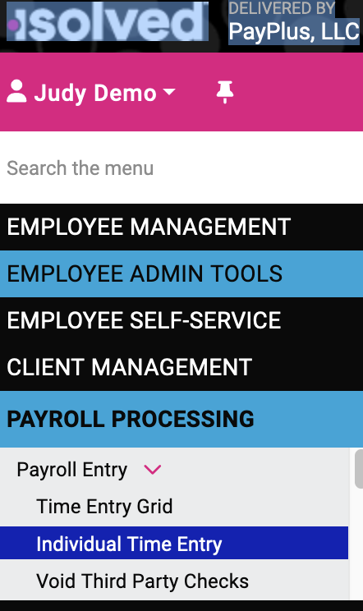

- Select the employee.
- On the Individual Time Entry screen, click Add New and then select the Check Type. The Default Check option will deduct the regular taxes for the employee. Gross Up lets you pay a bonus without having taxes taken out.

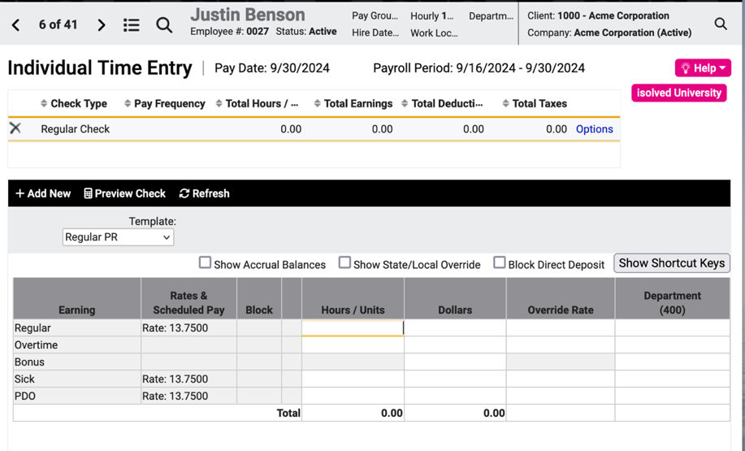

In this example, the employee is to get the full amount before taxes, so we select as the Check Type the Gross up option and isolved will calculate the pay amount to cover the taxes.

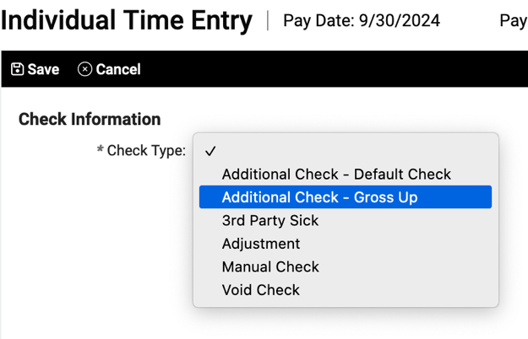

Click Save and you will return to the Individual Time Entry screen where you can enter the hours or dollars to be paid on the second check. In this example, we are paying a bonus of $1500 net and allowing deductions.

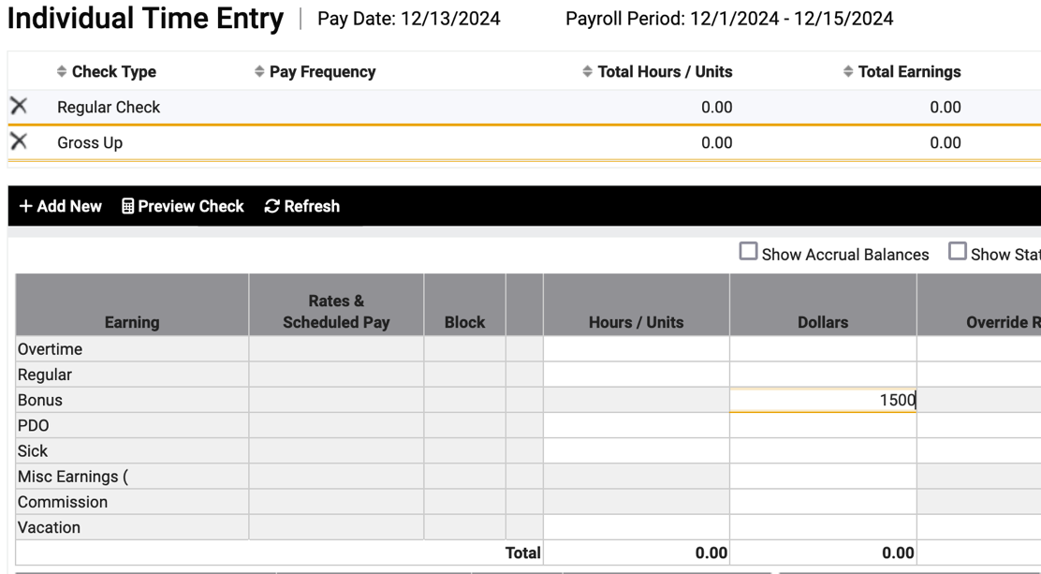

Click Preview Check to review and confirm the check date and to choose which of the employee’s available bank accounts the payment should be deposited to.

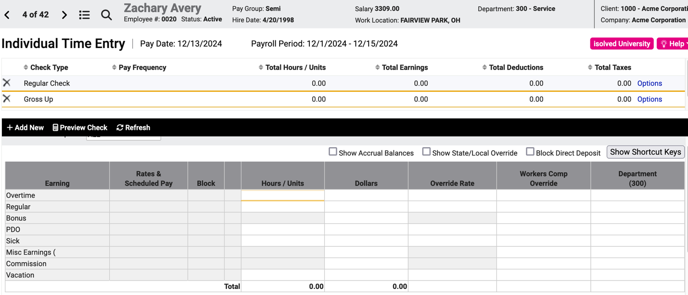

Here’s what the preview looks like:

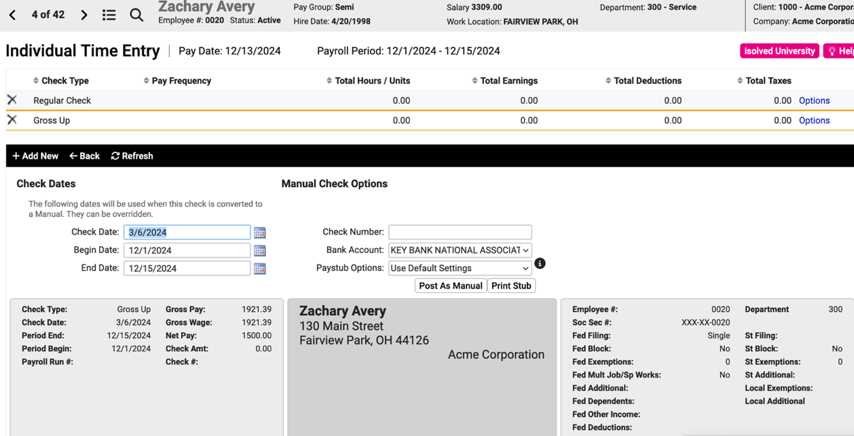

Let’s say we decide now to change or withhold deductions. Go back to the Individual Time Entry screen and select ALL from the template drop-down to show all the deductions and taxes for this employee.

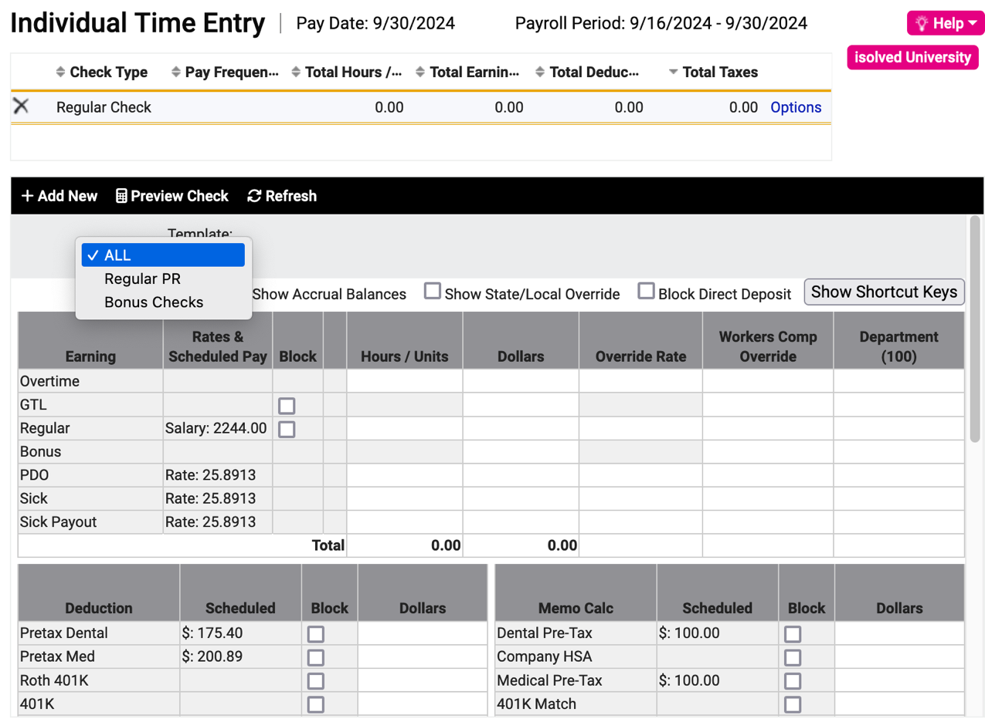

Check off Block next to the deductions you wish to block or change. To change the deduction amount for this check only, enter a dollar amount.

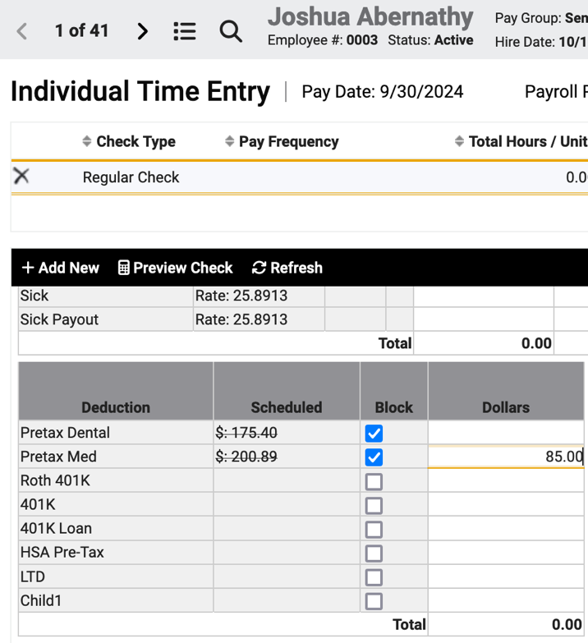

Tip: If you often issue bonus checks with no deductions, then you can create a Time Entry template called Bonus checks already set up this way.

To block taxes from being deducted or to change the tax amount(s)

You do not need to do this if you have grossed up the pay to cover the taxes!

You might see a box for changing taxes. Don’t go there! Many tax errors cannot be reversed and those that can be fixed are subject to the timetable and efficiency of the IRS and/or your state’s Department of Revenue. You will likely never need to block or change taxes—nor should you unless you understand the implications of these changes. Check the boxes for any tax you want to withhold or to change. You can enter a different amount or leave the field blank to suppress the tax entirely.

As always, you should make changes to an employee’s withholding taxes in the employee’s record, or by submitting a change form to your Payroll Specialist.

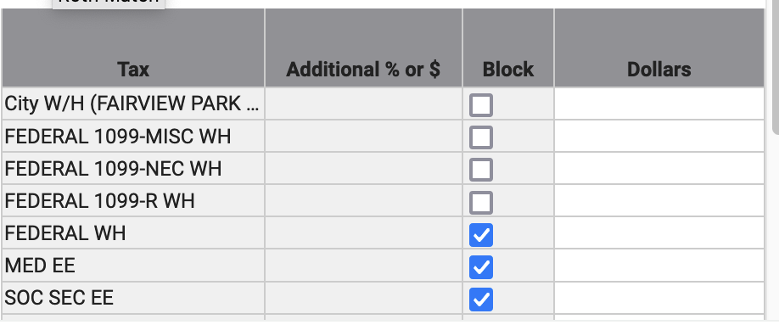

Video
https://learning.myisolved.com/library/quick-help-videos/entering-an-additional-check.

