Combining multiple reports into a single document

You can combine individual reports into a single continuous PDF to download or print.

- On the Reporting menu, select Continuous Reports Archive.

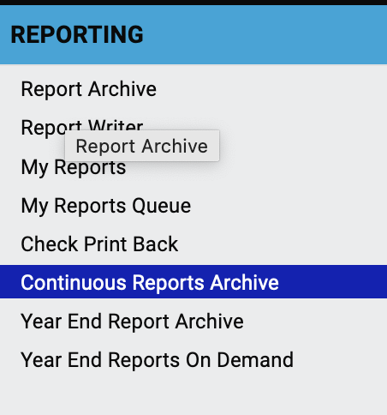

- Click the magnifying glass icon in the Actions column for the desired payroll run.

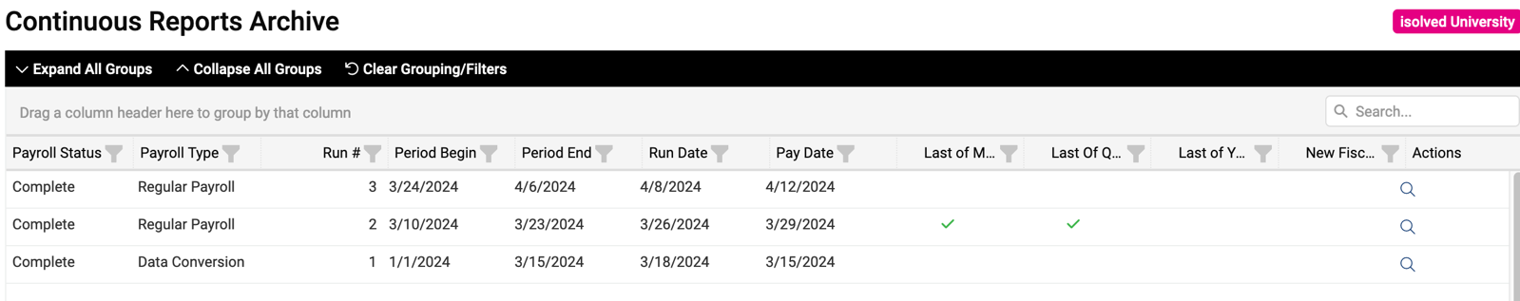

- All the reports for that pay run will be listed. Select individual reports or Select All as desired.

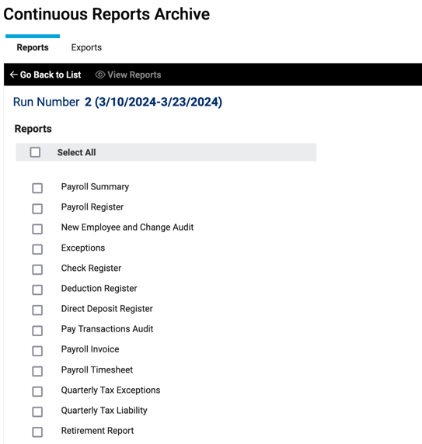

- Click View Reports. A PDF report with all the selected payrolls will be generated. Depending on your browser settings, the report might open in a new window or tab.

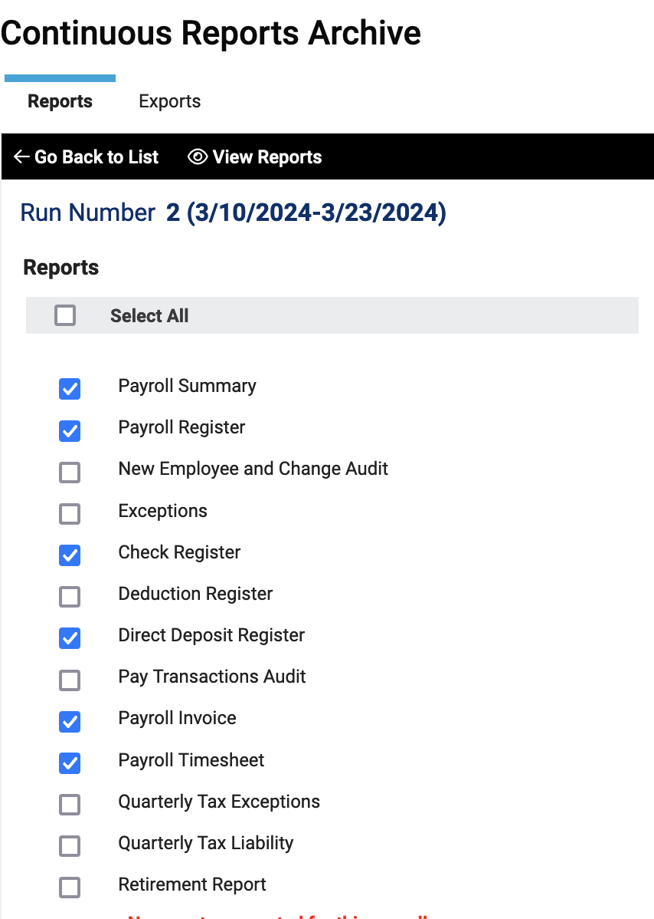

Video

https://learning.myisolved.com/library/quick-help-videos/utilizing-continuous-reports-archive

