Employee Self-Service (for employees)

If you have questions, see your supervisor. Do not call or email the payroll company. For security and privacy reasons, we do not communicate with employees of our clients.

How you can view pay stubs, pay history, and year-to-date tax info
- Log into isolved using the link in the email notifying you that your pay stub is ready. If you forgot your password, use the reset link in the email. Or login with https://payplus.myisolved.com (not isolved.com).
- On the Employee Self Service menu, select Pay History. You will see all your pay stubs for the current year. Pay history is available in isolved from 2024 and later.

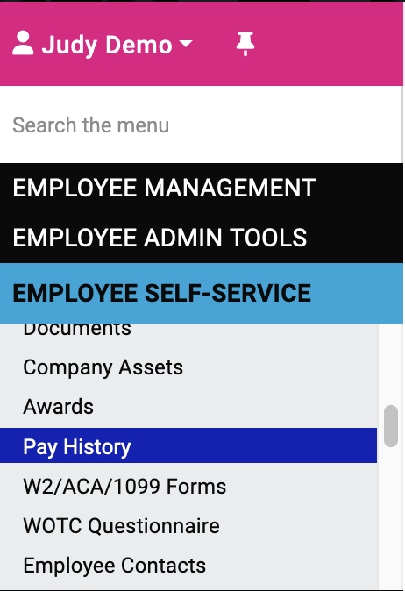

- To view an individual pay stub, find the check that you are looking for in the list on the pay history screen.

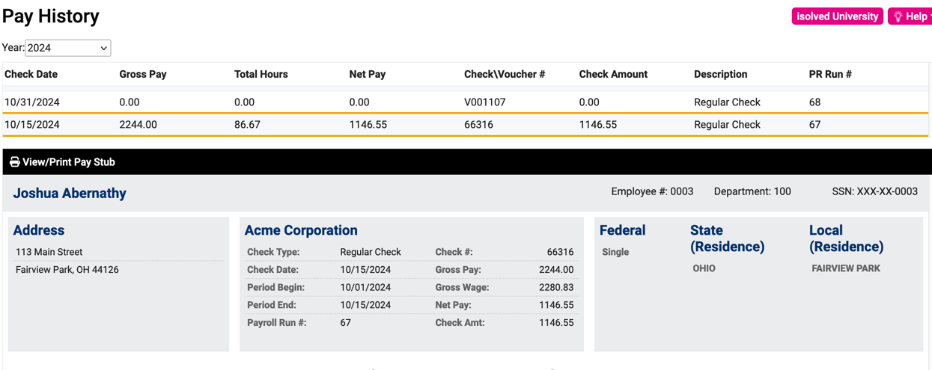

- Click on that specific check to view the details. You can see the number of hours, dollars, and year-to-date (YTD) information for earnings, deductions, and deductions.
- If you would like to print a copy of the pay stub, click on View/Print Pay Stub. A copy of the pay stub will open in a separate window. You can print your pay stub from here.

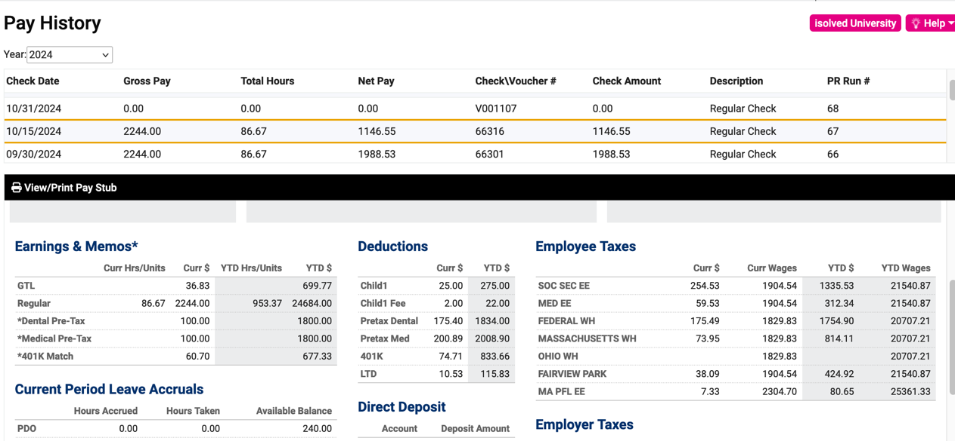

How you can view your W2s and 1099s
Tax documents are available in isolved only for tax year 2024 and later.
- Log into isolved: https://payplus.myisolved.com
- On the Employee Self-Service menu, select W2/ACA/1099 Forms.

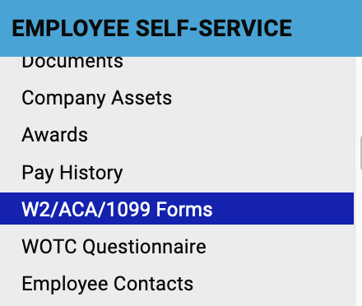
- Select the document that you wish to view from the list and click View Document.

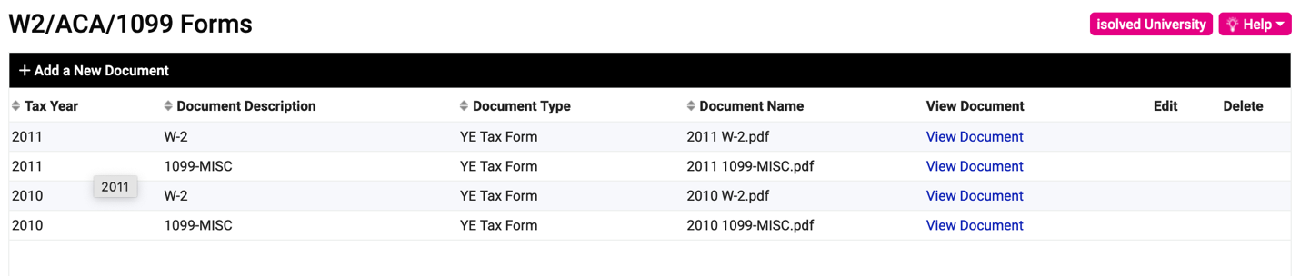

- The document you selected will open in a separate window, and you can print it from there.

Video
Employee self-service: view YTD pay history and YTD tax info
https://learning.myisolved.com/library/quick-help-videos/viewing-your-pay-history-or-w2

