Entering additional (second) checks

If you would like an employee to get two separate checks in the same pay period, such as separate checks for a bonus, commission, or overtime, here’s how to enter the additional check.

- On the Payroll Processing menu, select Payroll Entry and then Individual Time Entry.

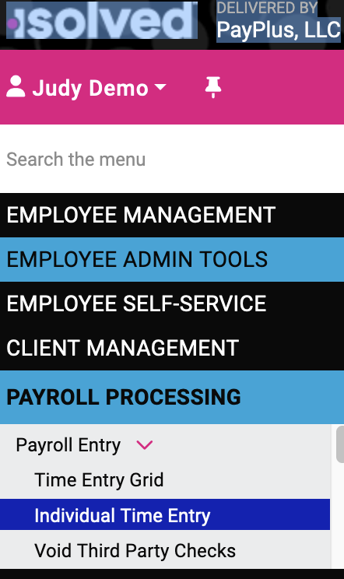

- Select the employee.
- On the Individual Time Entry screen, click Add New and then select the Check Type. The Default Check option will deduct the regular taxes for the employee. Gross Up lets you pay a bonus without having taxes taken out.

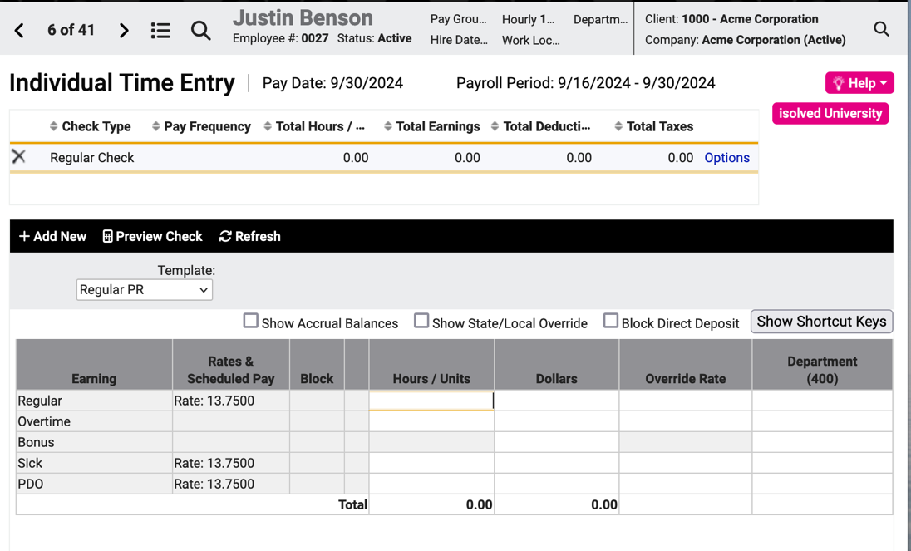
In this example, the employee is to get the full amount before taxes, so we select as the Check Type the Gross up option and isolved will calculate the pay amount to cover the taxes.

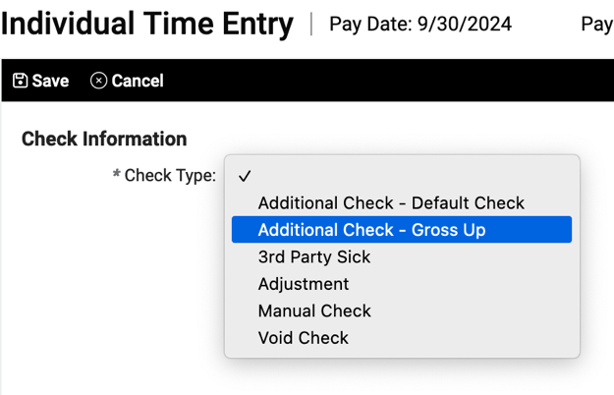

Click Save and you will return to the Individual Time Entry screen where you can enter the hours or dollars to be paid on the second check. In this example, we are paying a bonus of $1500 net and allowing deductions.

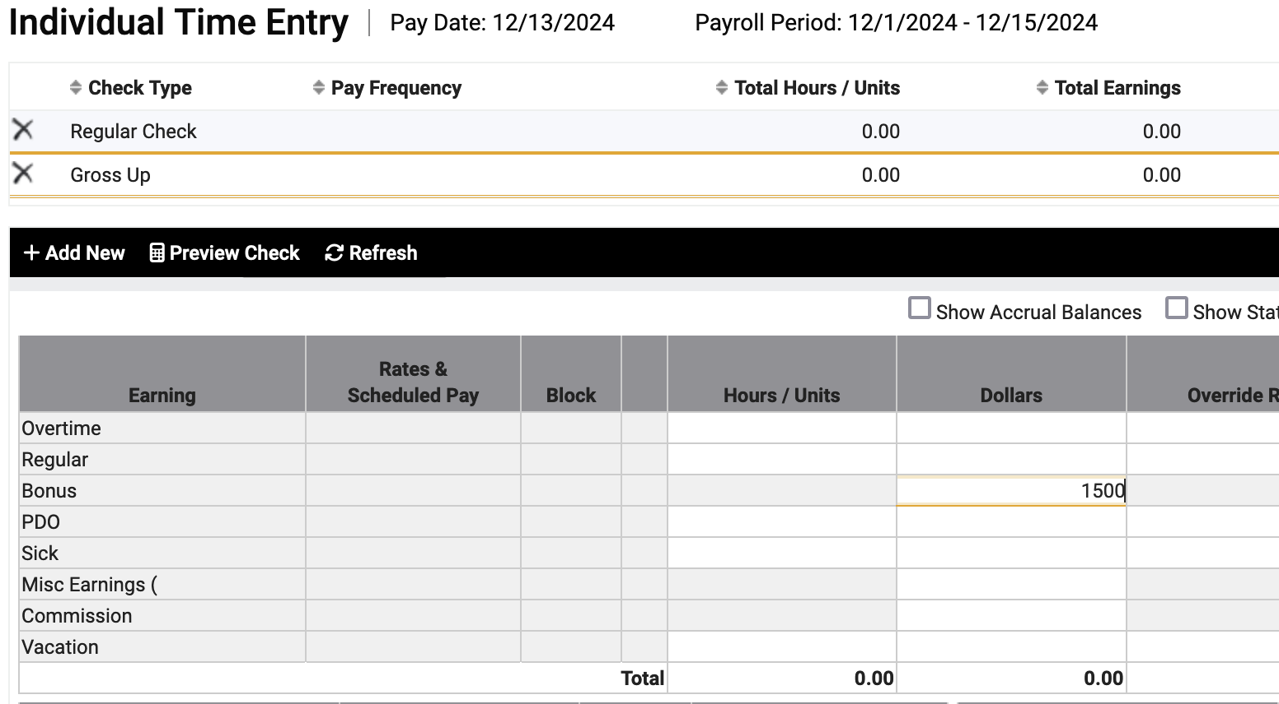

Click Preview Check to review and confirm the check date and to choose which of the employee’s available bank accounts the payment should be deposited to.

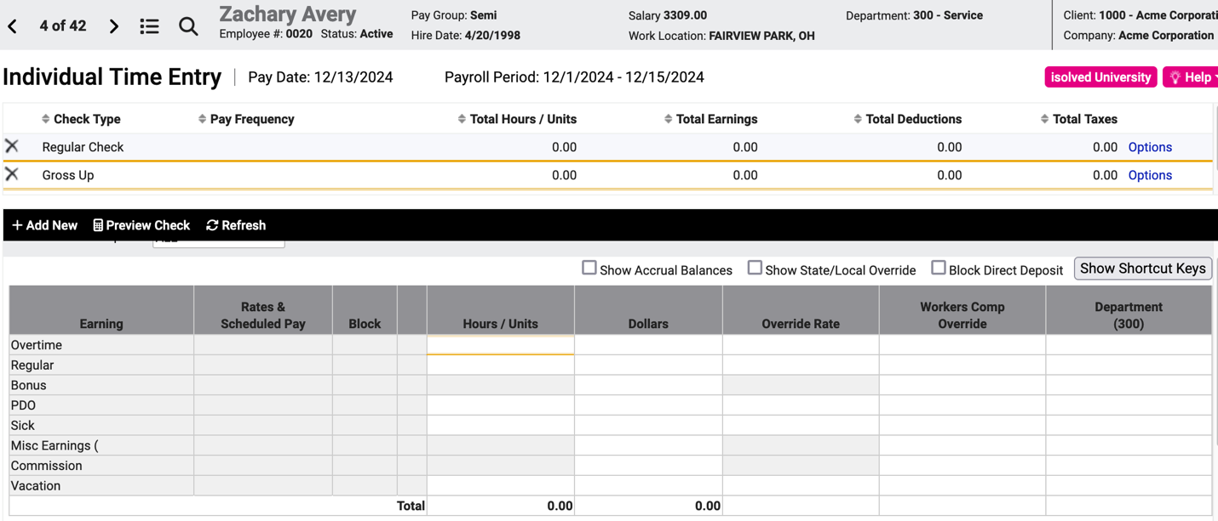

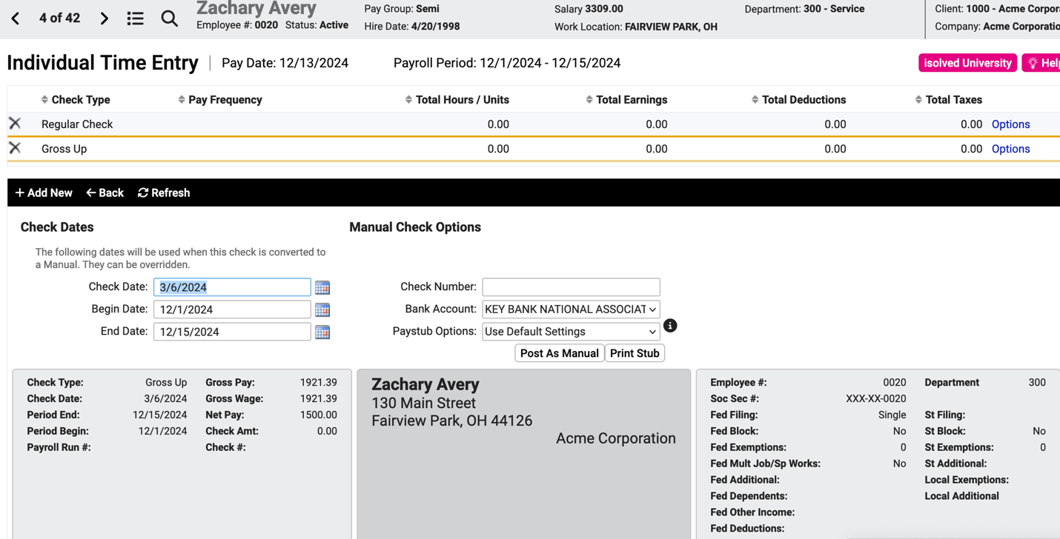

If you want this additional check to be processed and paid to the employee with the current payroll, then do not enter a check number and do not click Post as Manual Check.

Here’s how the check preview will look for this employee’s $1500 bonus (net, with deductions):

These instructions covered the simple case of issuing a second check to an employee on a regularly scheduled payroll.

If you want to issue a check between regular payroll runs (a manual check), ask your Payroll Specialist for instructions.

If you want to suppress or change deductions or taxes (major caution advised when tinkering with taxes), ask your Payroll Specialist for instructions.

Video
https://learning.myisolved.com/library/quick-help-videos/entering-an-additional-check.

