Entering manual checks

If you need to pay an employee outside of the usual pay date, you would create a manual check. A manual check can be paid through direct deposit (in 3 business days) or immediately, with you writing a physical check. If the manual check is to be paid by direct deposit, then ask your Payroll Specialist to run an additional payroll. These instructions are for when you write out a live check. Either way, the deductions, taxes, accruals, etc. will be accounted for in the payroll software so records are correctly updated.

- On the Payroll Processing menu, select Payroll Entry and then Individual Time Entry.

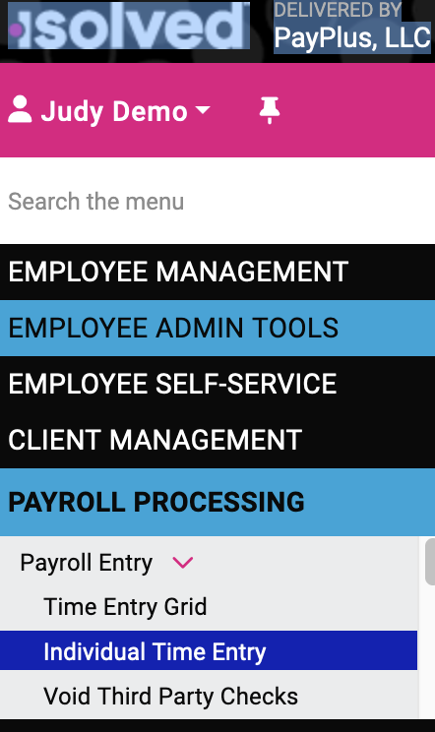

- Select the employee.
- On the Individual Time Entry screen, click Add New.

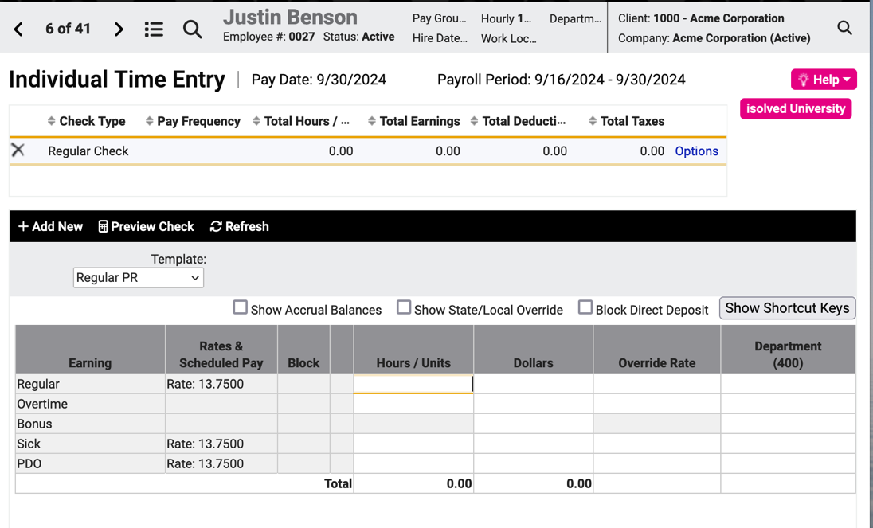

Select the Check Type (Manual Check) and enter the Check Date. If you are writing a physical check, use today’s date.

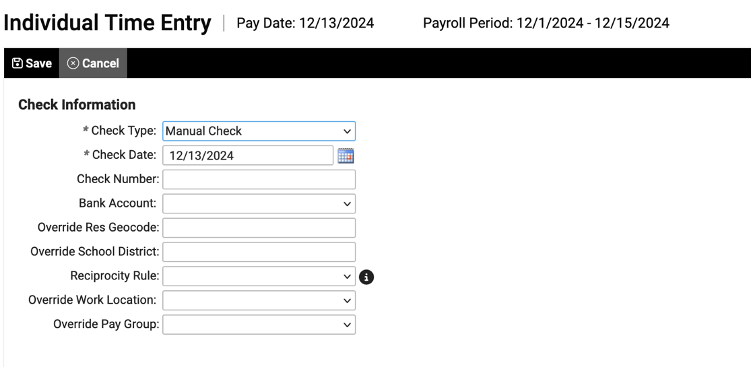

Click Save and you will return to the Individual Time Entry screen where you can enter the hours or dollars to be paid on the manual check. In this example, we are paying 8 hours of regular pay and 2 hours OT.

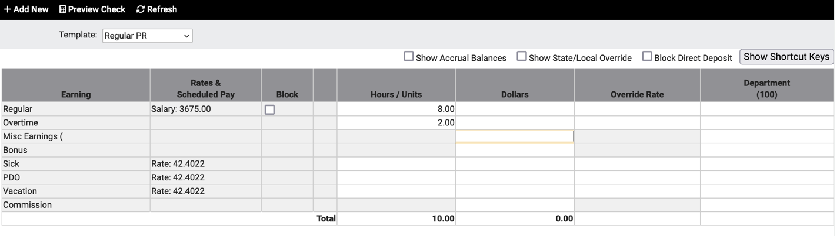

Check Block Direct Deposit so the employee doesn’t get paid twice. Click Preview Check to review.

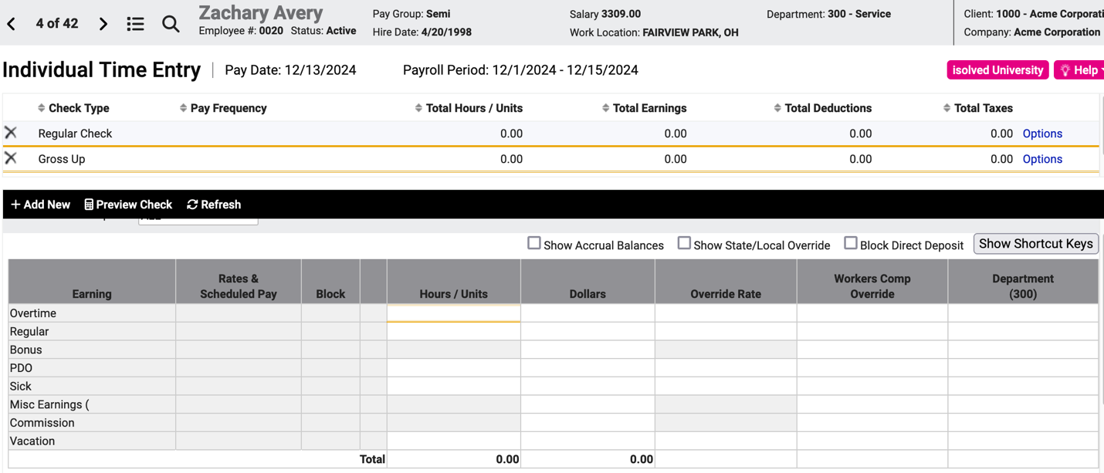

Here’s how the check preview will look for this employee’s manual check. The direct deposit information should be blank—if not, go back to the Individual Time Entry screen and check off Block Direct Deposit.

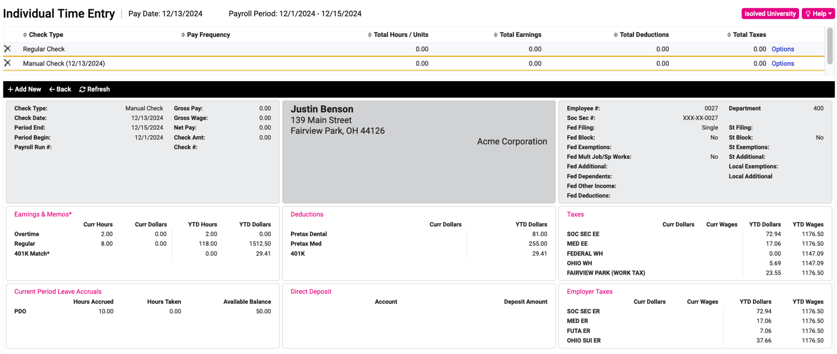

The manual check will be posted with the next payroll run.

Video
https://learning.myisolved.com/library/quick-help-videos/entering-an-additional-check.

