How to get help in isolved

If you have a question or get stuck using the isolved software, here are some resources.
Tip: isolved works best on Chrome and Edge, so if you are having difficulty, try changing browsers.

Find a menu
Type what you’re looking for in the search box. The results shown are live links, so you can click on the menu name you are looking for and that menu will open.

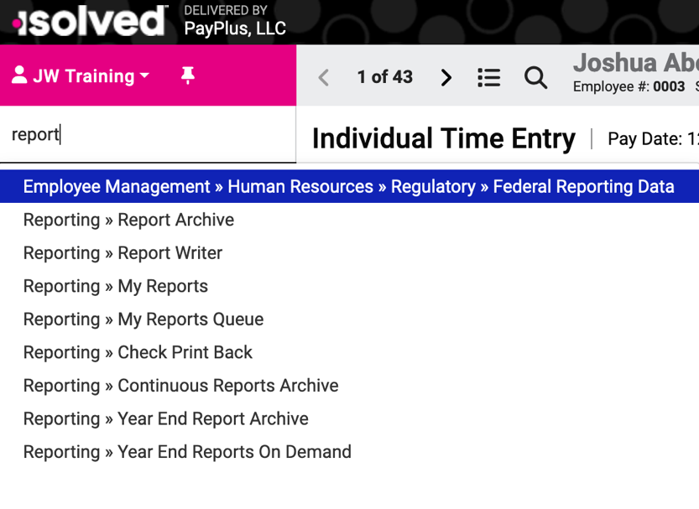

Get written and video instructions
Click the Help button on the far right of most screen to see topics relevant to that screen. These are also live links. Click the isolved University link to go to the University where you can find short videos (most under 5 minutes), articles, and, if you are really ambitious, full-fledged courses.



Sign up for one-on-one training
We recognize that changing software might be daunting for clients, so we are providing live, one-on-one training for anyone who requests it. There is no charge for this training, which can be done via phone or Zoom, but you will need to schedule it in advance with judy@paypluspayroll.com.

