How to view isolved videos

If you do not like to read instructions, you can view videos in isolved University instead. We recommend course path “Introduction to Payroll” for an excellent overview.

- Log into isolved and under your name, click University.

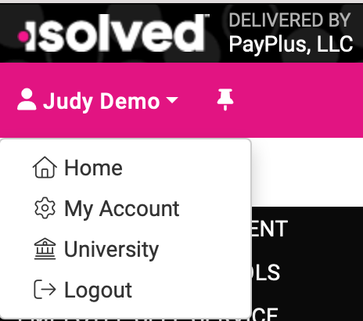

The first time you do this, you will need to create an account for the University website. Select Merge to use the same username and password you set up for isolved.

The University has courses and articles about isolved.

If you have questions on specific items, the Quick Help videos are excellent resources. Click Search to enter keywords to find videos and articles about how to use isolved.



