Rehiring an employee

If you want to rehire a former employee who was on payroll in 2023 or later, then all you need to do is reactivate them in the software, confirm that the employee’s information has not changed, and add their Direct Deposit information.

- On the Employee Management menu, select Employee Summary.

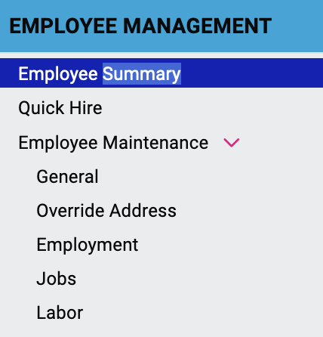

- Click Status to see the dropdown menu where you can choose to view Active or Terminated employees. Select Terminated.

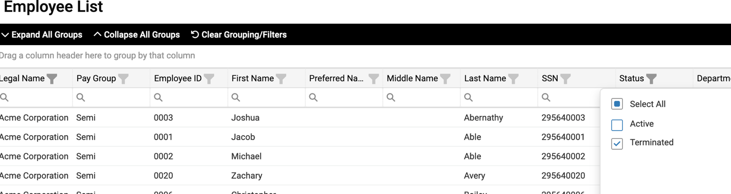

- Select the employee you want to rehire. On the Employee Management menu, select General to see the employee’s record.

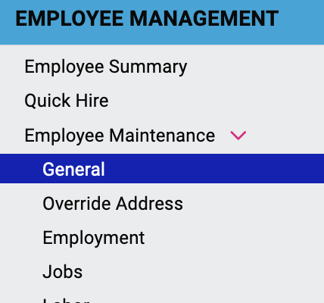

- Click Rehire.

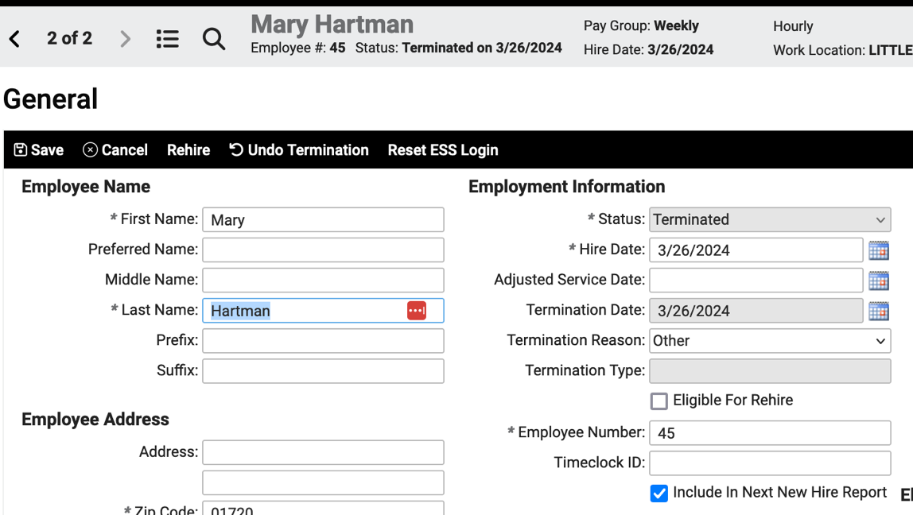

- Check the Rehire button. (You can do this even if there is a Warning that the employee is flagged as not eligible for rehire.) The Rehire Date will default to today’s date, so enter the correct date if different.

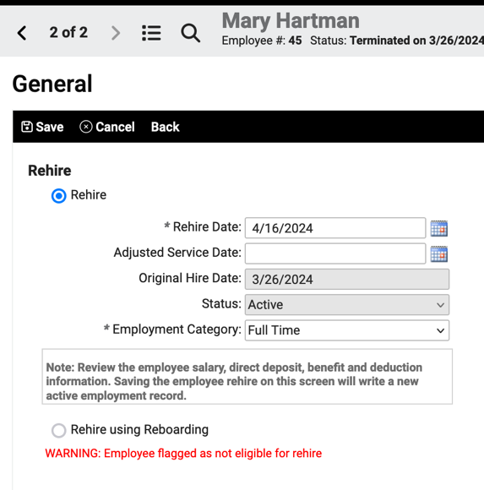

- Click Save. The employee will receive an email with a link to activate their Self-Service account.

You will need to add the Direct Deposit information, as that is not imported from the old records. You should also confirm with the employee that their address, tax withholding, marital status, and any other information has not changed.

