Viewing and printing reports

Report archives for current or old payroll reports

On the Reporting menu, select Report Archive to see a list of all the reports created with each payroll that was run.

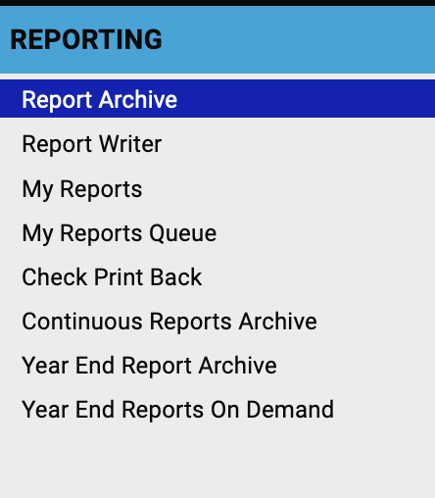

Select the pay period for which you want the report. The dates are for the pay period, run date, and pay date.

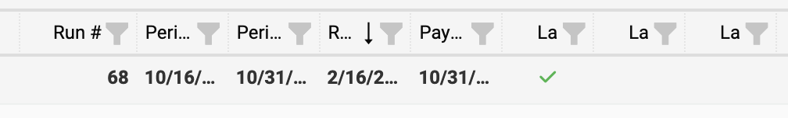

Click the arrow to display all the reports from that pay period.

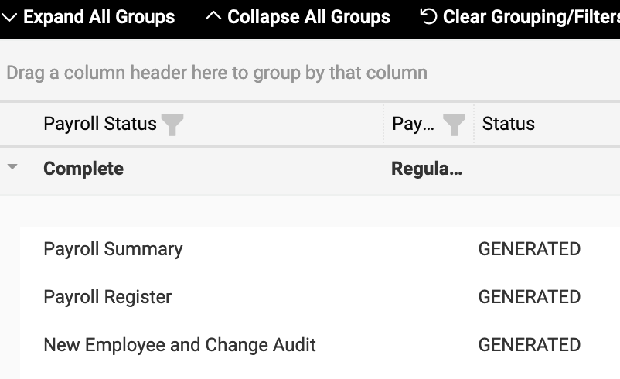

Select the desired report and in the Actions column, click the icon to view or download the report. Depending on your browser settings, the report might open in a new window or tab.

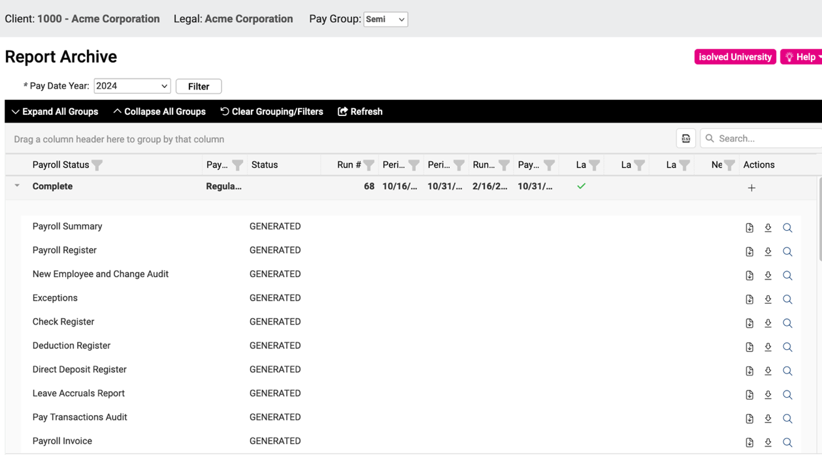

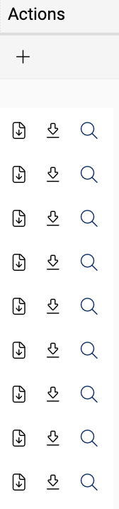
Download

View

Running current reports

Use these instructions if you want to run reports other than the usual reports that are generated with each payroll. You would typically do this for something out of the ordinary, such as if you needed an Employee Pay History report.

On the Reporting menu, select My Reports.
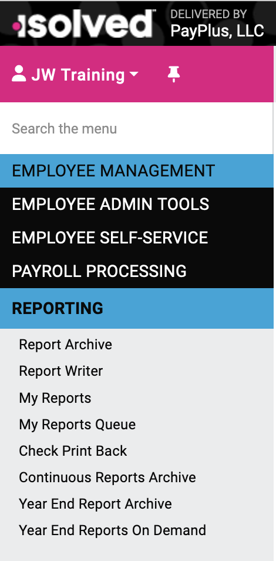

You will see all reports available for you to run in alphabetical order.

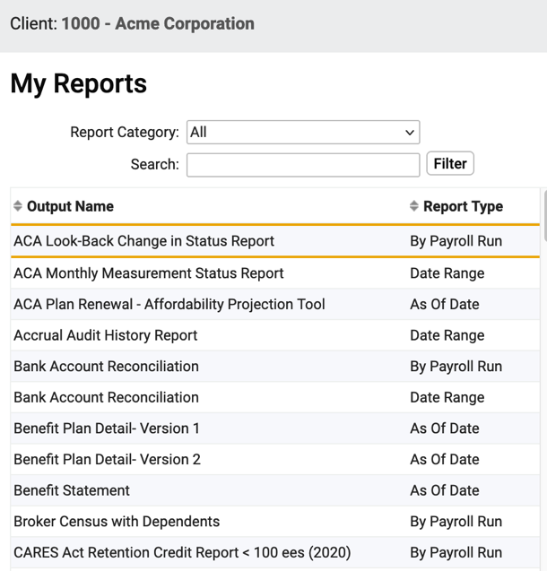

You can sort these reports by report type. You can run reports for a specified date range by specifying the From Date and To Date. (This is useful for generating reports for Workers’ Comp audits. In fact, there is a report called Employee Workers Comp Summary.) As Of Date (applicable only to some reports, such as Employee Profile) runs a report based on that specific date. By Payroll Run generates a report for a single, specified payroll run.

Select the report, enter any required dates or select the desired payroll run, and click Generate Report.

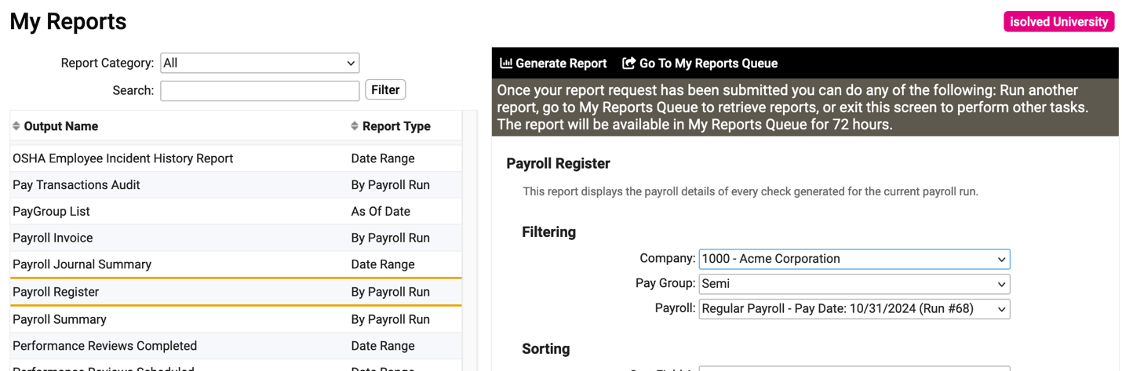

When the report is generated, it will show up in My Reports Queue and be available there for 72 hours. (Reports older than that can be viewed from Report Archive.)

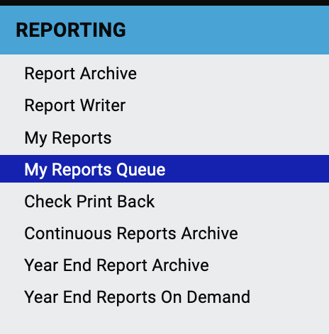

Click View Report to see the report. The report will open in a new window, from which you can download or print the report.

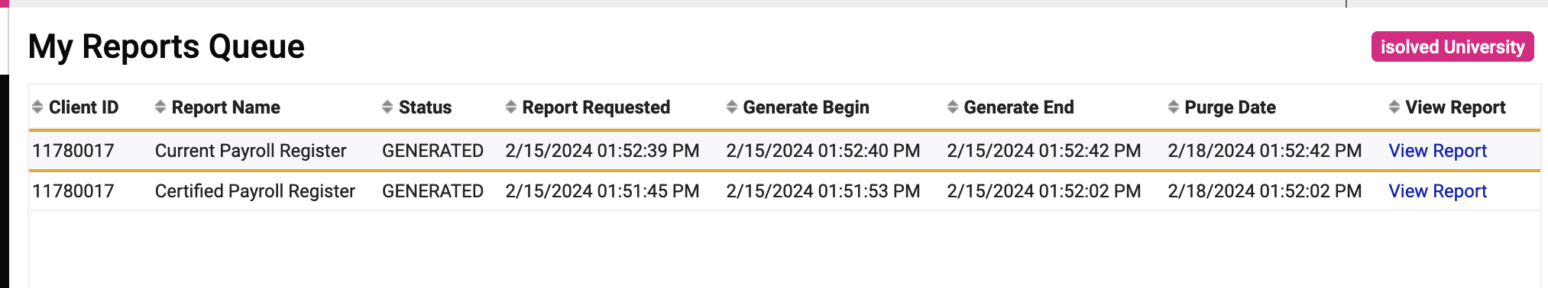

Videos
Current reports
https://learning.myisolved.com/library/quick-help-videos/running-client-reports

Current or past reports
https://learning.myisolved.com/library/quick-help-videos/viewing-payroll-reports-using-report-archive

