Setting up direct deposit for an employee

When setting up direct deposit, make sure the employee has given you proof of the routing number, account number, and type of account (checking or saving). For checks, get a voided check. For accounts without checks (savings account, online banks), have the employee get a letter from the bank. All banks, including online banks, have a form for this.

Triple check that you have entered the account number correctly. If you enter an incorrect account number, the employee’s pay will be deposited to that account and, depending on the financial institution and timing, you might lose that money. For example, if the person whose account the funds are incorrectly deposited to withdraws the money and closes the account, then the money cannot be pulled back. In addition, NatPay (the clearing house for processing transfers between financial institutions) levies a fine for incorrect/non-existent accounts—a fee that is passed on to you.

Changes to direct deposit accounts

If an employee requests via email that you change their bank for direct deposit, confirm with that employee by phone or face-to-face (NOT email) that they made the request. If the employee’s or your email was hacked, that request could be bogus. This is just one example of payroll fraud that has been occurring around the country.

Setting up direct deposit

For a new hire, you can enter the direct deposit information on the Quick Hire screen.

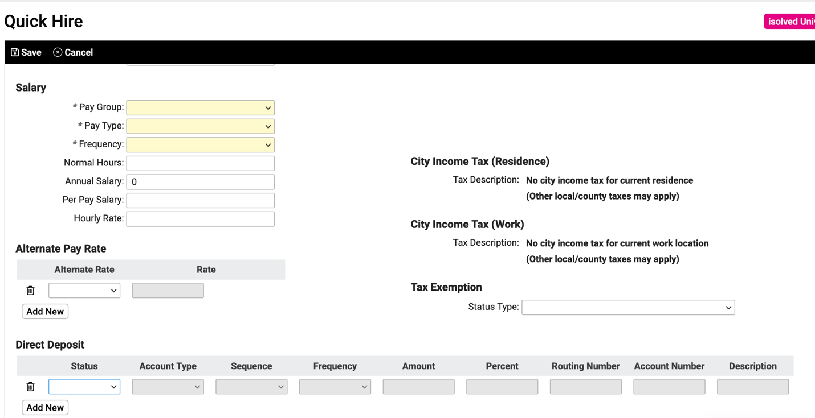

Or you can add or change direct deposit information later. On the Employee Management menu, select Employee Pay and then Direct Deposit.

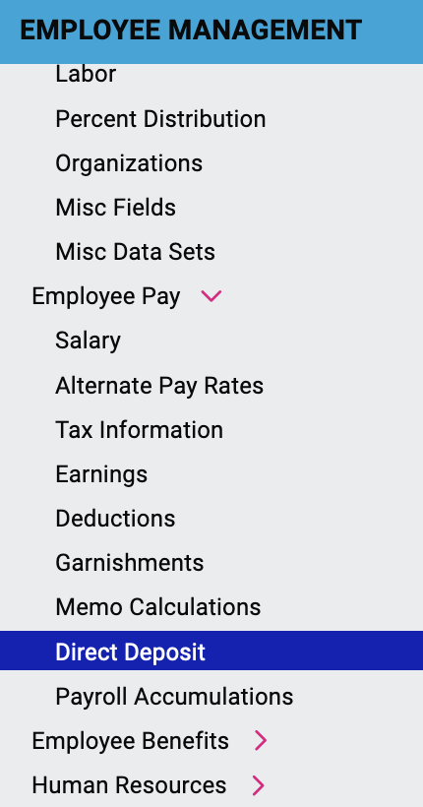

Select the employee whose direct deposit you are adding.

If the employee already has direct deposit set up, this screen shows the currently active direct deposit accounts for the employee, and the details of the selected direct deposit.

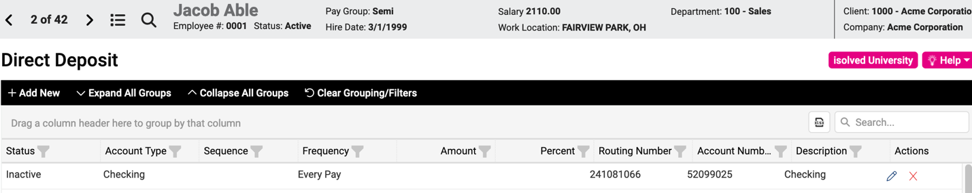

You can see the status, account type, routing number, account number, and description. In addition to these columns, it also shows the sequence and the frequency. Sequence refers to the order the pay is deposited if an employee has more than one bank account.

Splitting a paycheck between accounts
If an employee would like to split their paycheck between multiple direct deposit accounts, click Add New.

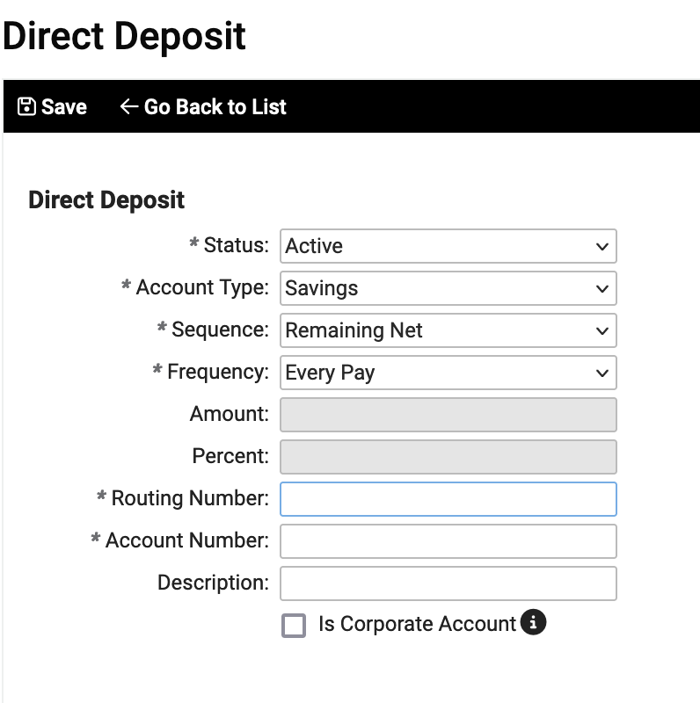

Enter the Account information (account type, routing number, account number, description). Specify the appropriate sequence and frequency. Frequency is likely to be Every Pay, but you can select a different option from the dropdown menu. The Sequence setting determines which account the paycheck is first deposited to and the subsequent order for depositing to other accounts.

If you are setting up multiple bank accounts for an employee, enter the information (the Amount or Percent of pay) for the account where funds are first to be deposited. This would have Sequence setting of 1. The other account should always be set to Remaining Net so that there are no unallocated amounts to the paycheck. For example, if an employee wants their paycheck split 90% in checking and 10% in savings, enter 90% for the Checking account and set that as Sequence 1. Do NOT enter 10% for the Savings account; instead put Remaining Net as the sequence.

You can give the accounts descriptive names (name of bank or type of account) so that the employee can see how their pay was allocated when they look at their paystub in Self-Service.

Video
https://learning.myisolved.com/library/quick-help-videos/adding-an-employee-s-direct-deposit

