Terminating an Employee

Terminating an employee, whether a voluntary or involuntary termination, follows the same procedure.

- On the Employee Management menu, select Employee Maintenance and then select General.

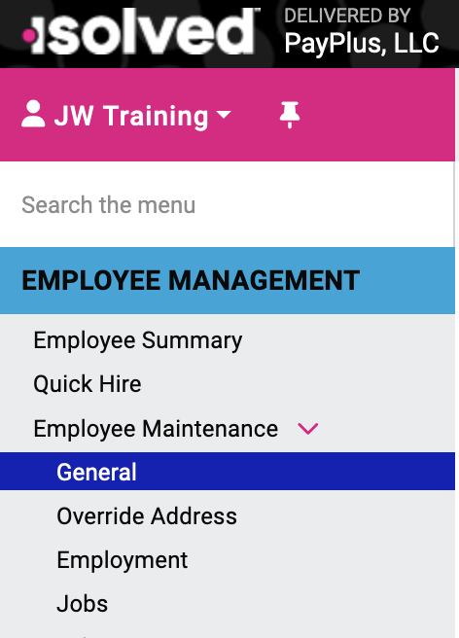

- Scroll to find the employee you are terminating and double-click on their name.

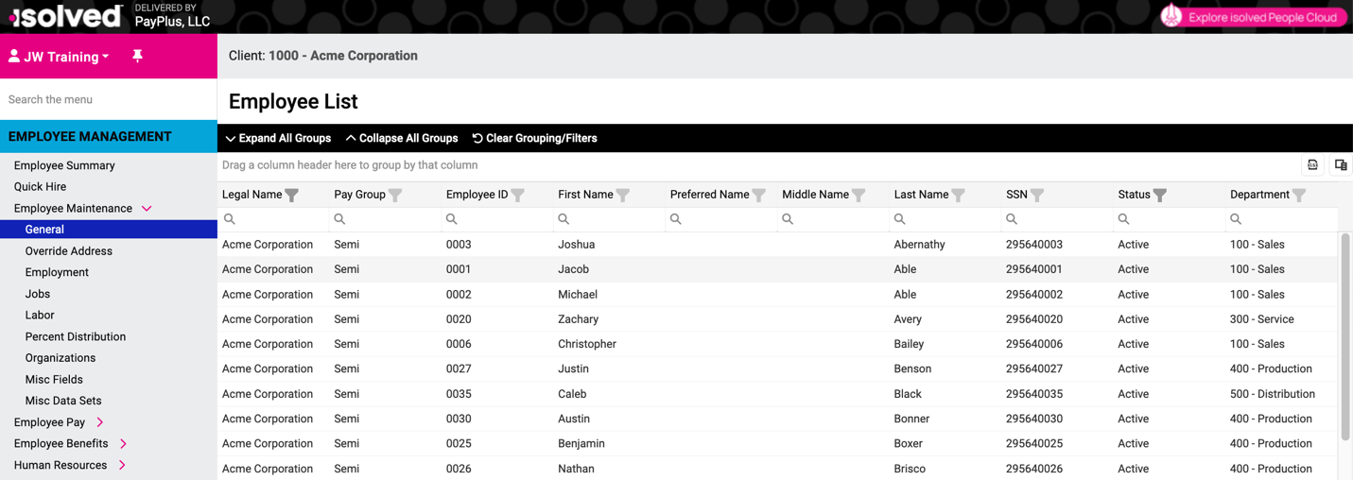

- Click the Terminate button.

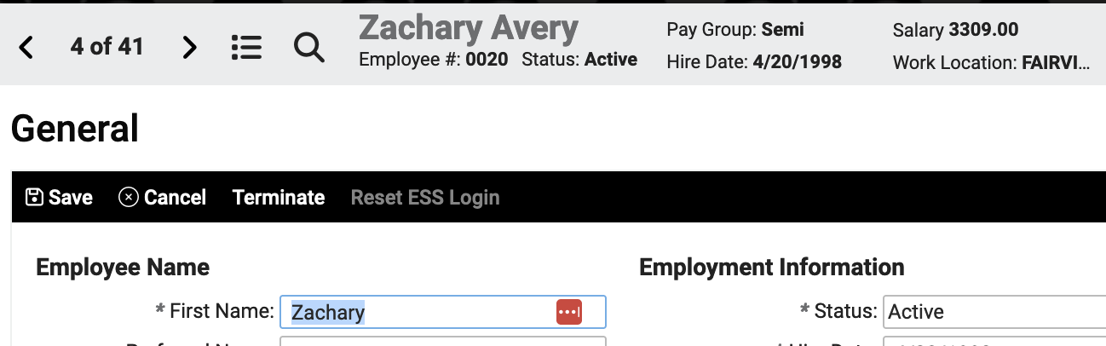
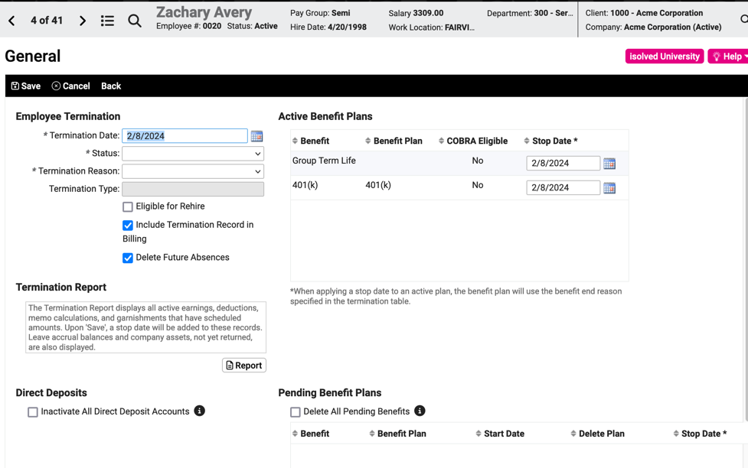

- Enter a Termination date and select the Status and a reason. The reason will automatically populate the Termination Type information box.

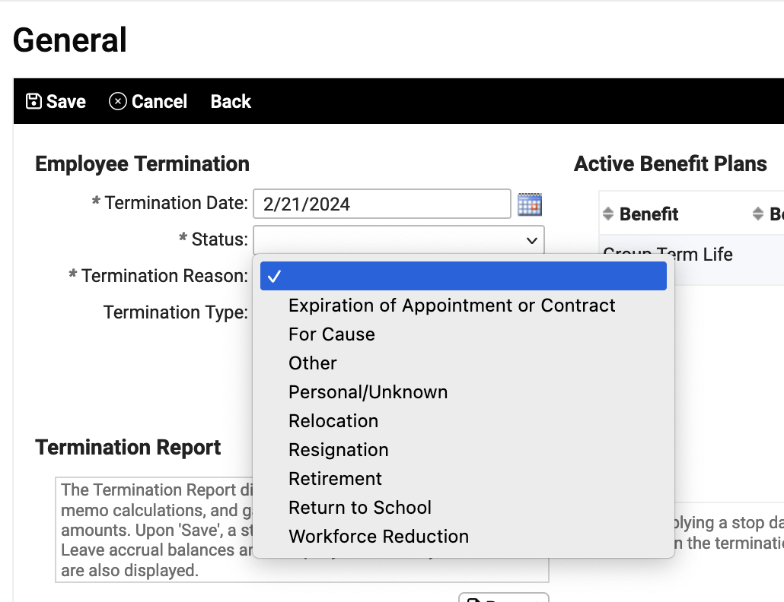

- Check the appropriate boxes if this employee will be eligible for rehire and whether any future absences should be deleted
- You can also choose to inactivate direct deposit accounts and stop any active benefit plans.
- Click Save and the employee will be terminated as of the Termination Date that you entered.

Video
https://learning.myisolved.com/library/quick-help-videos/terminating-an-employee

