Viewing a list of all employees

There are several ways to view a list of all employees. Here are 3 ways.

- On the Employee Management menu, select Employee Summary.

All the names are live links, so you can click any name to pull up that employee’s record.

You can sort the lists by clicking on the column header. For example, if you want to sort by Department, click on the Department heading, or to list employees alphabetically by first name, click on the First Name heading.

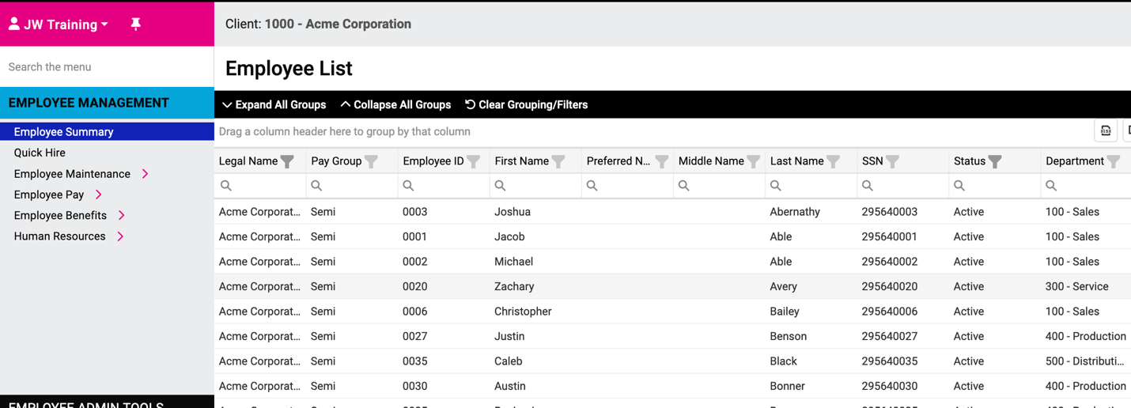

- Or on the Employee Maintenance menu, select General. These are also live links and you can sort the employees the same way as on the Employee Summary screen.

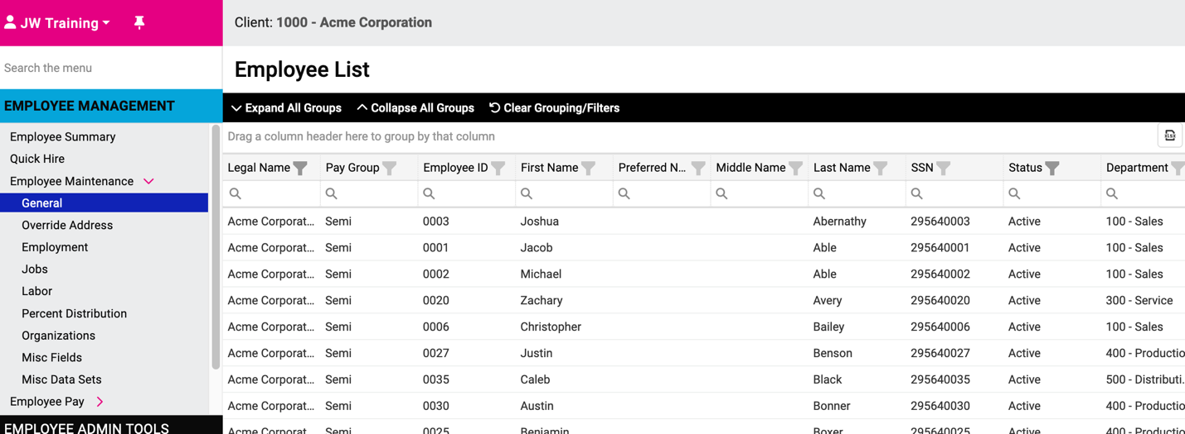

- Several screens have a link to the employee list. The link, which looks like a bulleted list, is shown below. If you click on that icon on any screen where it appears, a list of all employees will be displayed. You can click on the < and > icons to page through the employees.

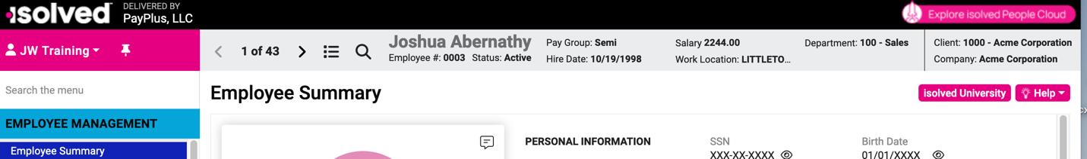

The default list is Active employees only. To view Terminated employees, click Status to see the dropdown menu where you can select to show terminated employees as well as, or instead of, active employees.

