Viewing and Printing Year-End Reports

Year-end reports for payrolls run in isolved will be available only for 2024 year-end and later.

- On the Reporting menu, select Year End Report Archive.

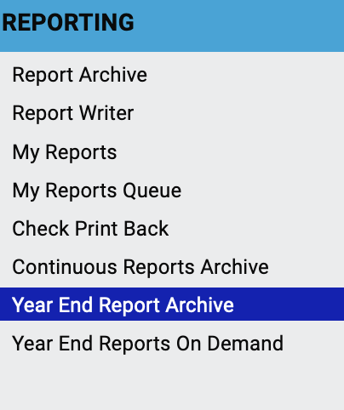

- Select the year and the desired report. In the Actions column click the icon to view or download the report.

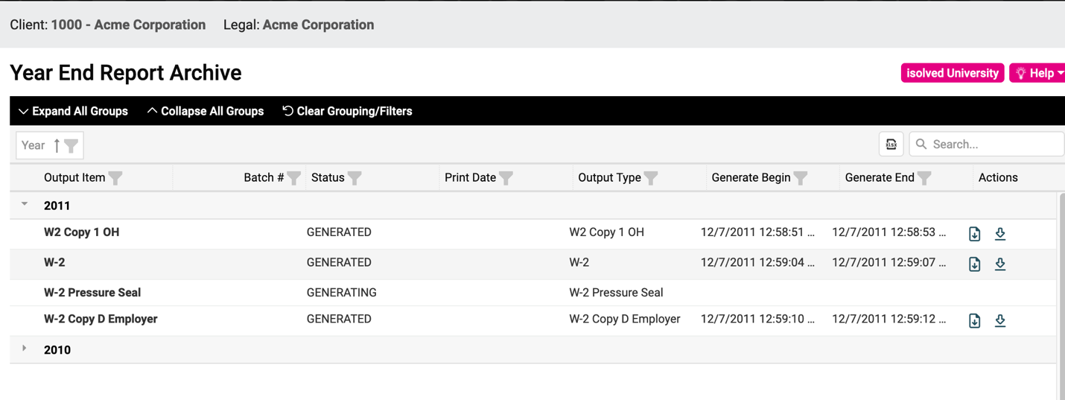

If the Year End Report Archive doesn’t have the report you’re looking for, you can generate a report using Year End Reports On Demand.

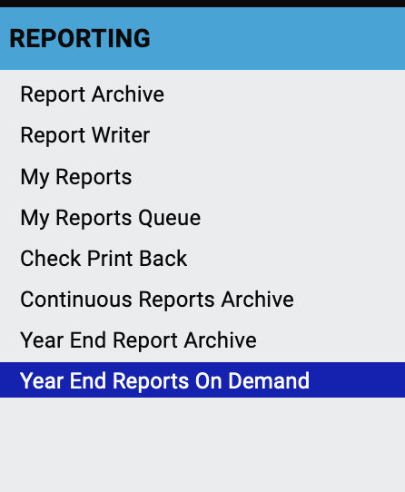

Select the report, enter the date, and generate the report. You can generate 1099s and W2s as well as several other year-end reports.

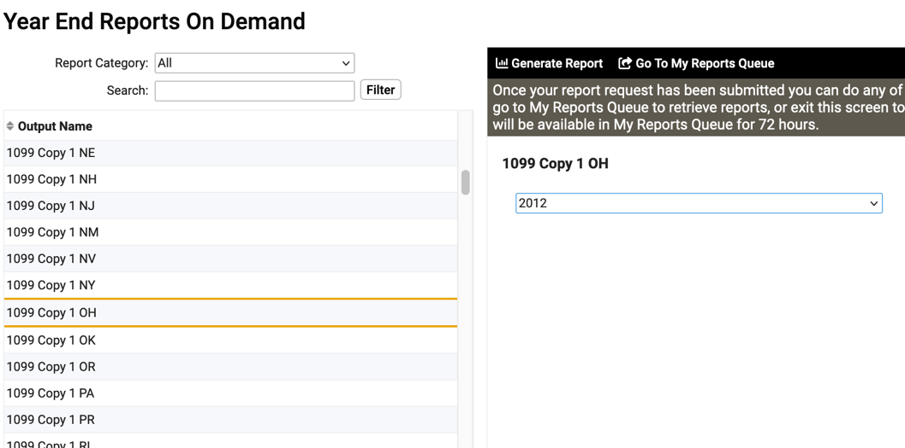

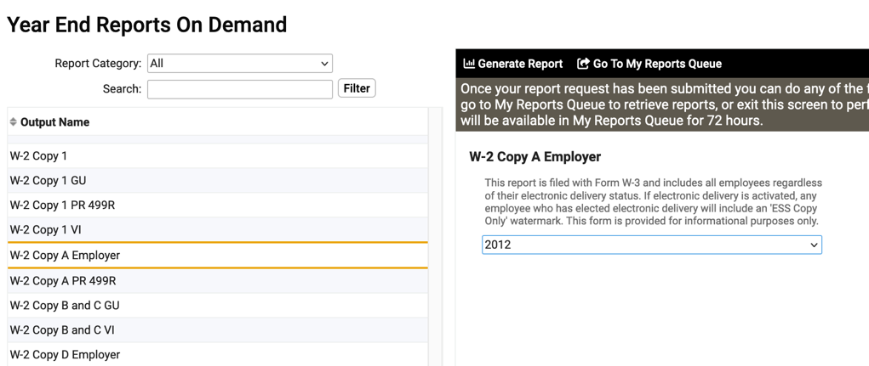

Depending on your browser settings, the report might open in a new window or tab. Print the report from your browser, as usual.

Video
https://learning.myisolved.com/library/quick-help-videos/viewing-year-end-reports-using-year-end-report-archive

