Viewing and printing quarterly reports

- On the Reporting menu, select Return Archive.

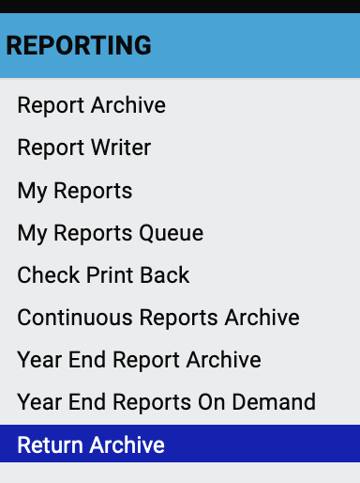

- Select the reports you want by year and period (quarter). Press Filter to confirm your selection. (You will not see any results until you press Filter.)

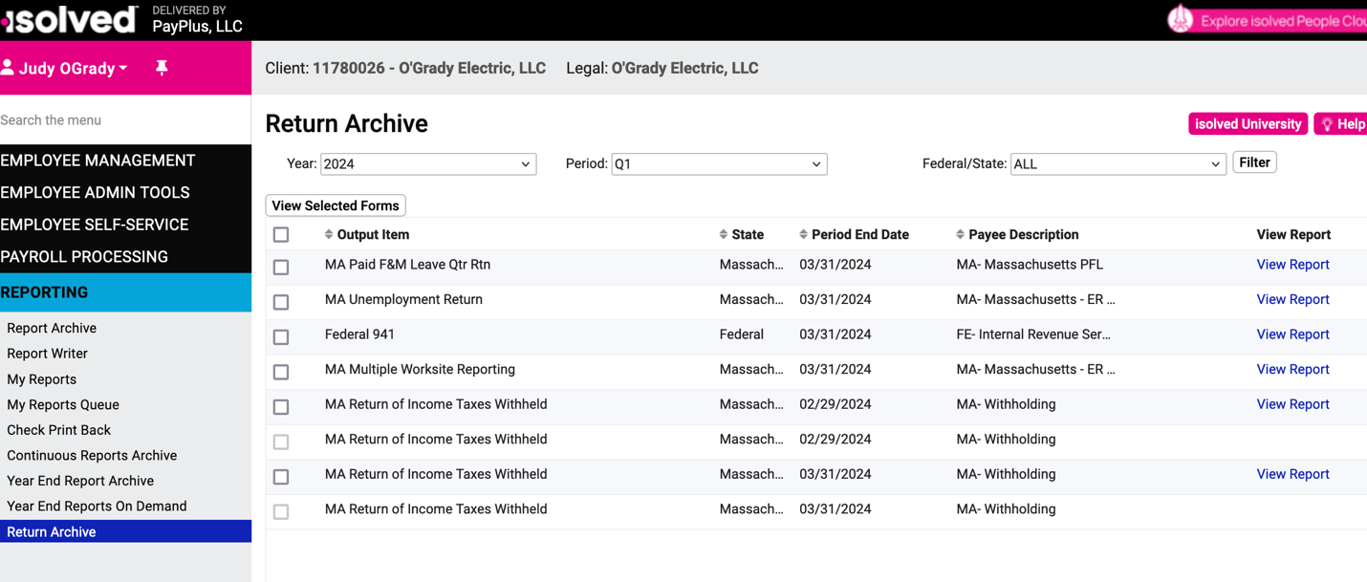

Click View Report to see the 941 Federal Quarterly Report.

- Depending on your browser settings, the report might open in a new window or tab. Print the report from your browser.

Quarterly reports
https://learning.myisolved.com/library/quick-help-videos/viewing-quarterly-reports-using-return-archive

