Entering payroll

You need to submit payroll three business days before payday. There are three steps to doing payroll: Payroll Entry, Process & Review Payroll, and Run Payroll Reports.

- Enter Payroll

On the Payroll Processing menu, select Payroll Entry, and then Time Entry Grid.

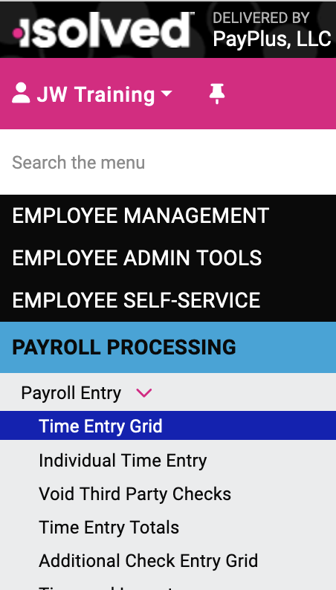

Enter hours and/or earnings in the Time Entry Grid.

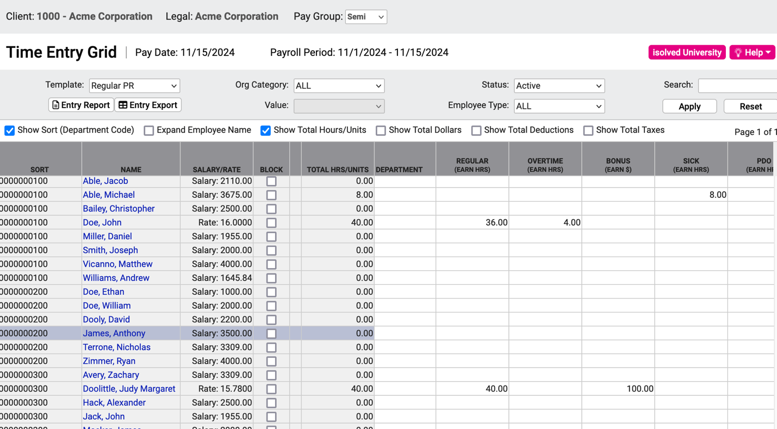

- Salaried people are paid automatically; don’t enter their regular salary but do enter any other pay types, such as vacation, sick time, PDO (Paid Day Off). You can suppress pay for a salaried employee by checking off Block.

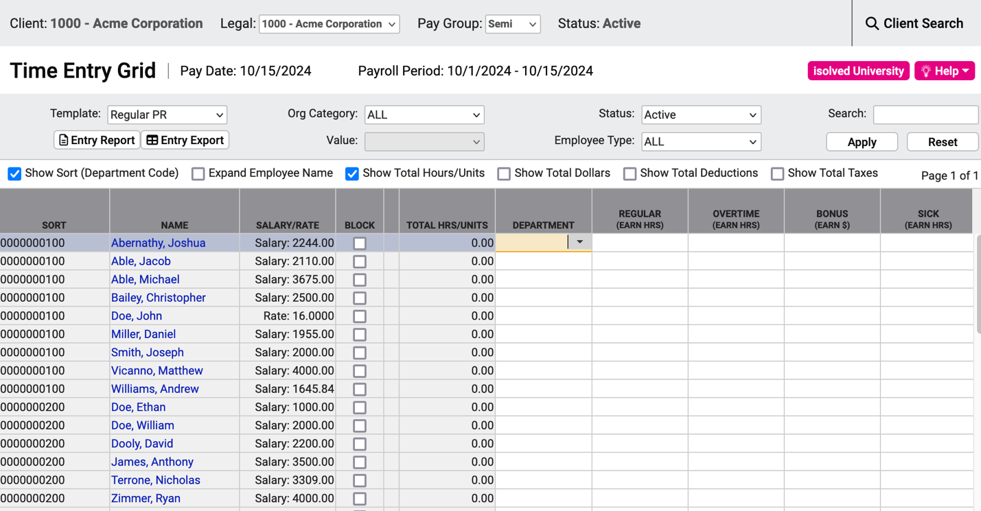

- You can also override the salary amount for the current pay period. Ask your Payroll Specialist for instructions on how to do this.
- Enter hours for hourly employees; if an employee has no hours this pay period, simply leave the field blank. (You do not have to enter 0.)
- If an employee has more than one job category, you can enter hours separately for each. In isolved, this is called “alternate pay.” Ask your Payroll Specialist for instructions on how to do this.
- If you need pay types not shown in the grid, ask your Payroll Specialist to set them up.

- Process and Review Payroll

After you enter the hours and earnings into isolved, you should review the calculated payroll on each of the standard reports to ensure the payroll is complete and correct.

A quick way to proofread your entries is to click Entry Report. You can export these to an Excel spreadsheet by clicking Entry Export.

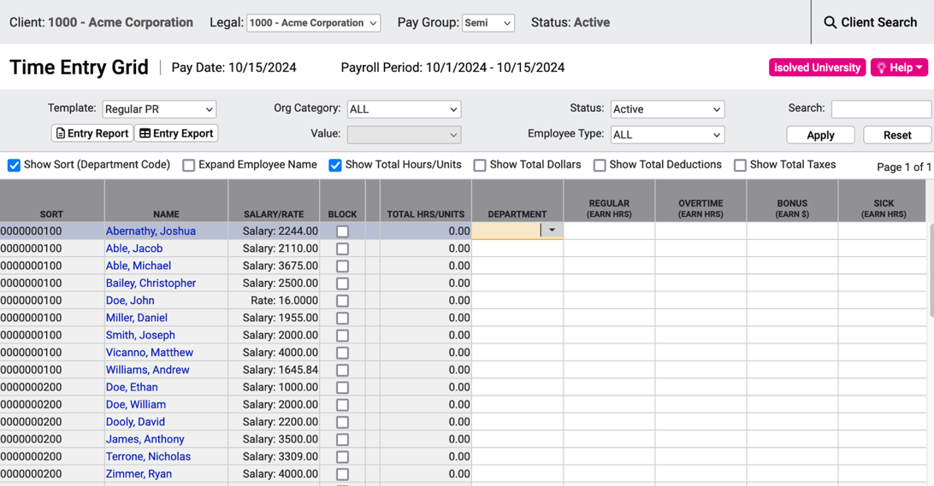

This report does not show information provided by the software such as taxes, deductions, or salaries; it shows only what you manually entered so you can proofread those entries without extraneous information. After you process the payroll, you can view the Payroll Register and Payroll Summary reports to view all details (taxes, deductions, salaries, etc.)

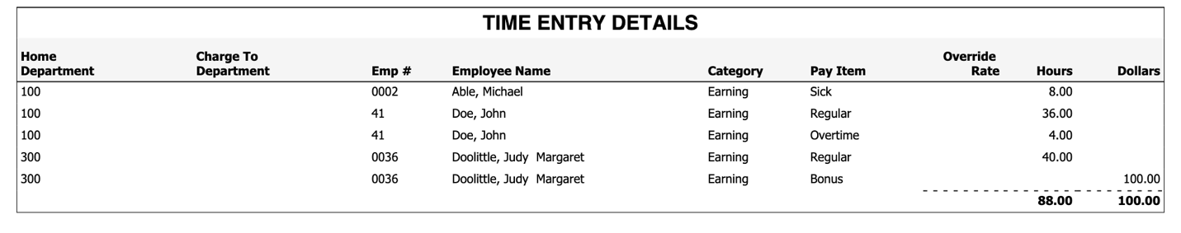

On the Payroll Processing menu, select Process Payroll.

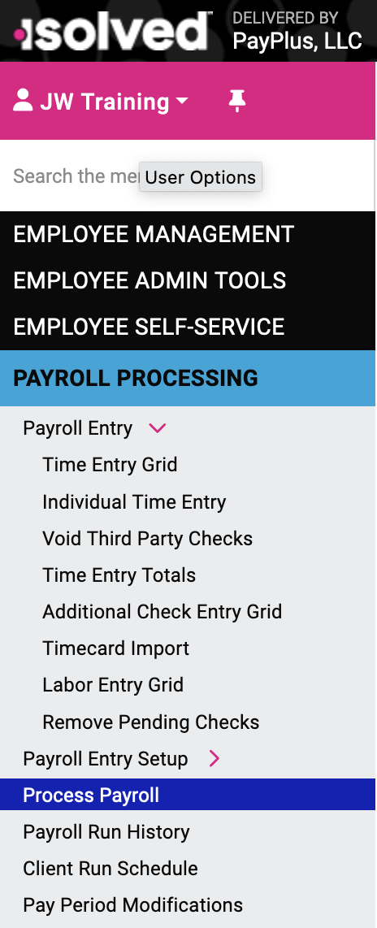

Click the Preview button. The software will calculate pay, deduction, and taxes, and generate reports for you to review for completeness and accuracy.
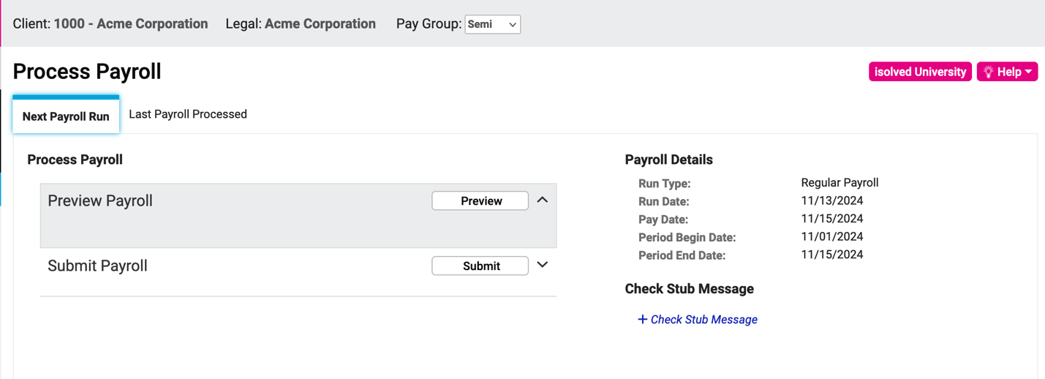

View payroll reports by selecting the Payroll Preview Reports drop-down menu and then click the Go button.

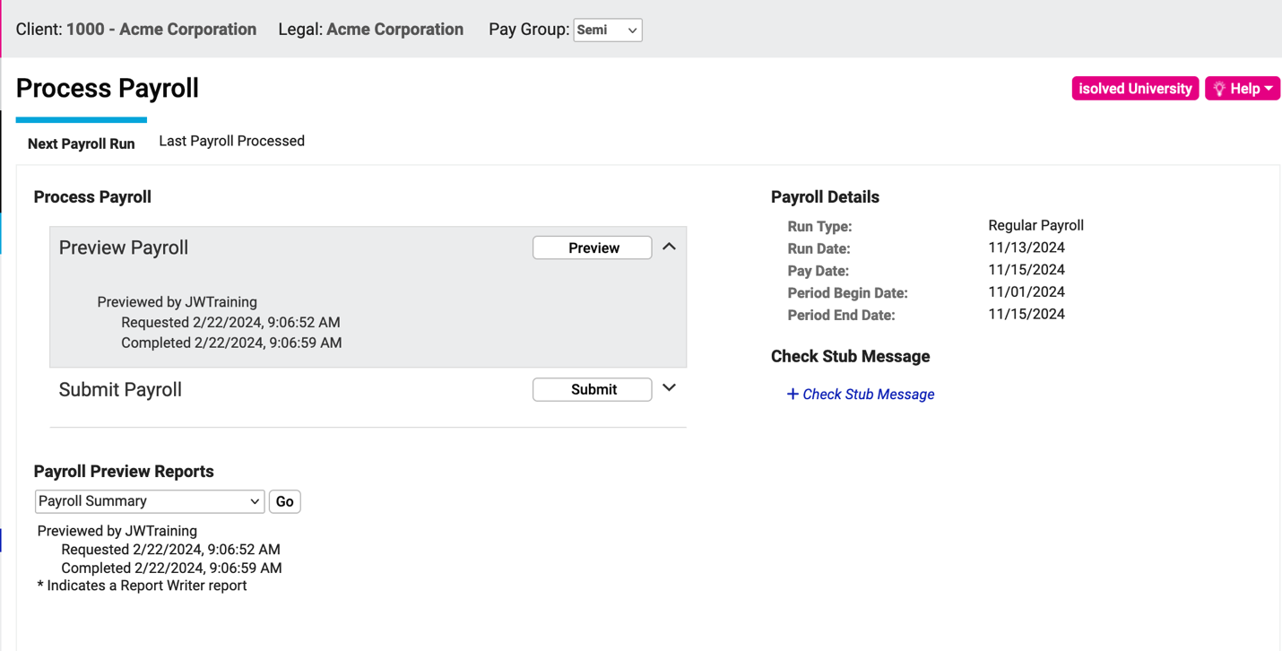

The Payroll Summary report shows calculations of payroll, deductions, and taxes for the entire payroll run. This report shows current, month-to-date, quarter-to-date, and year-to-date figures.

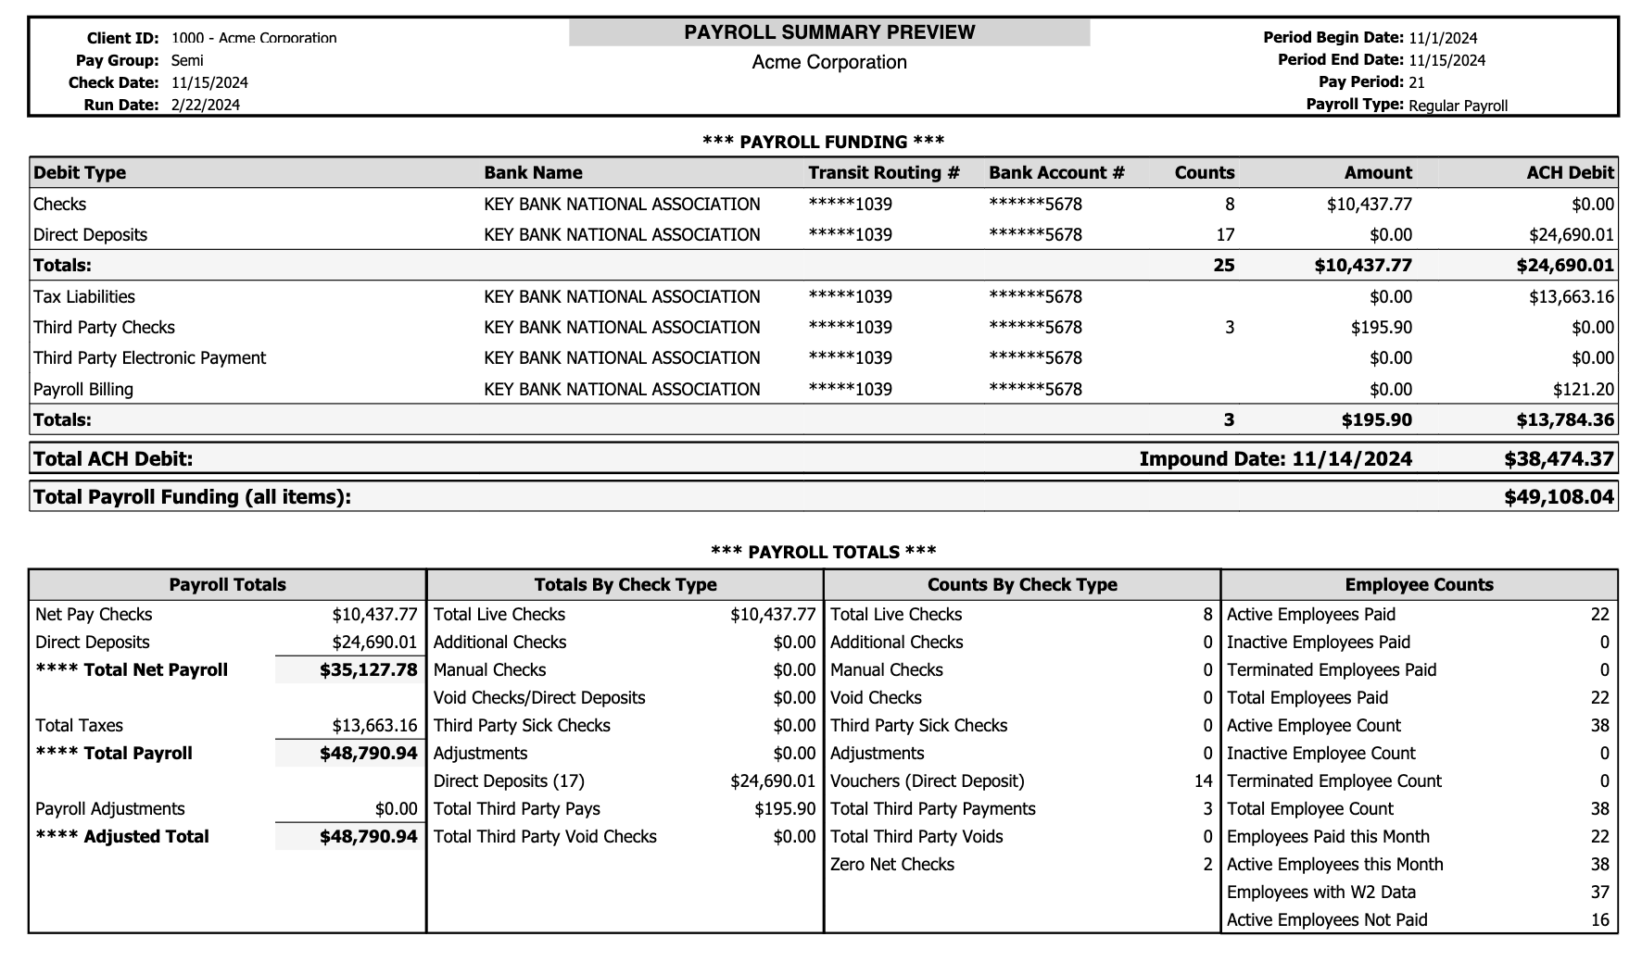
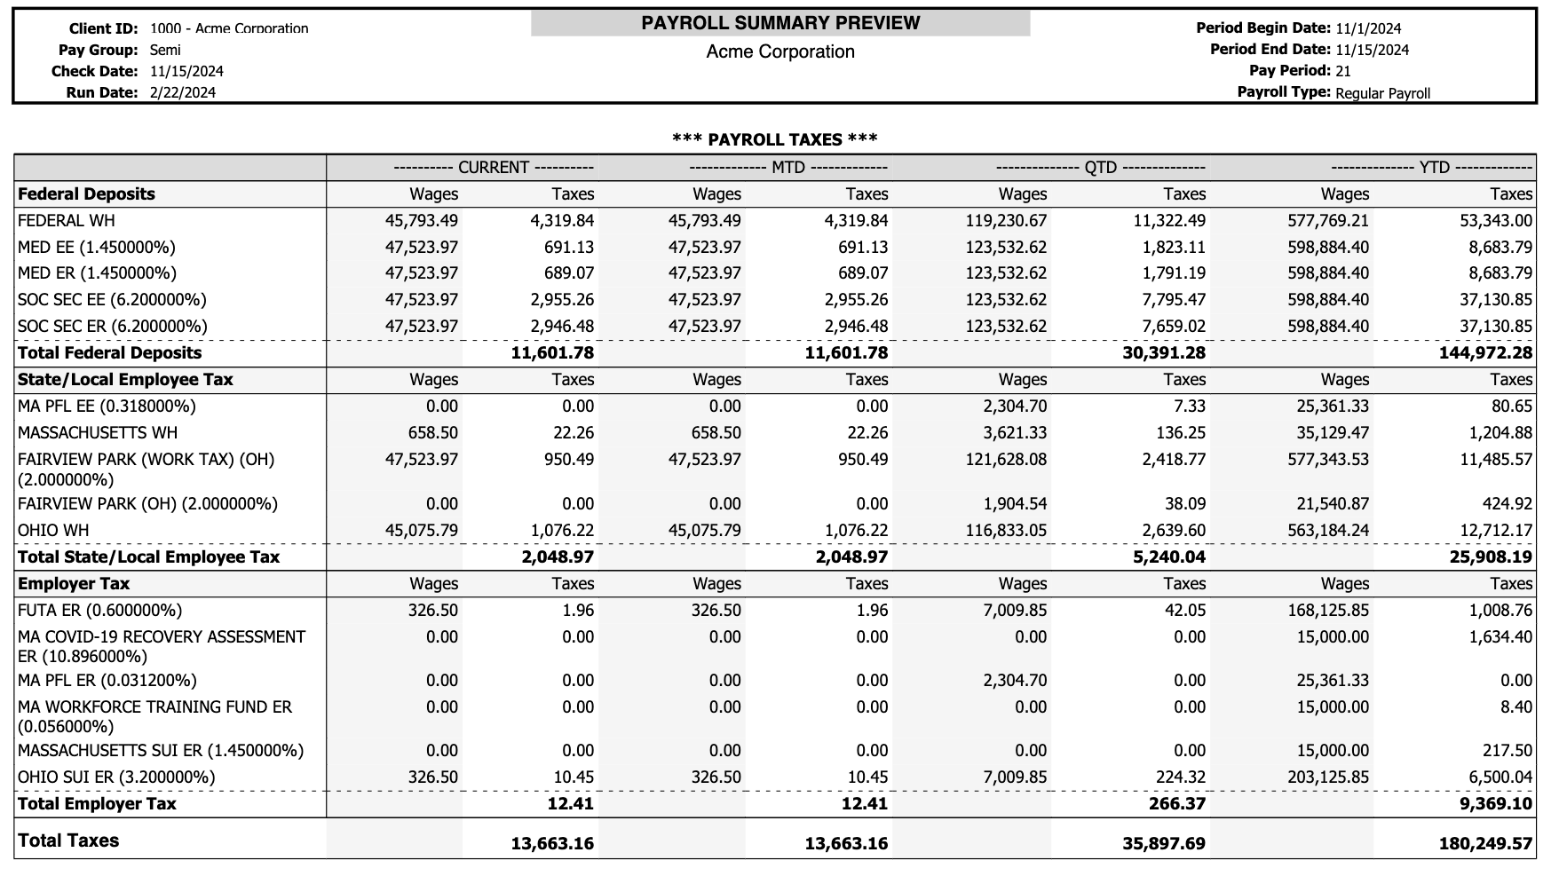

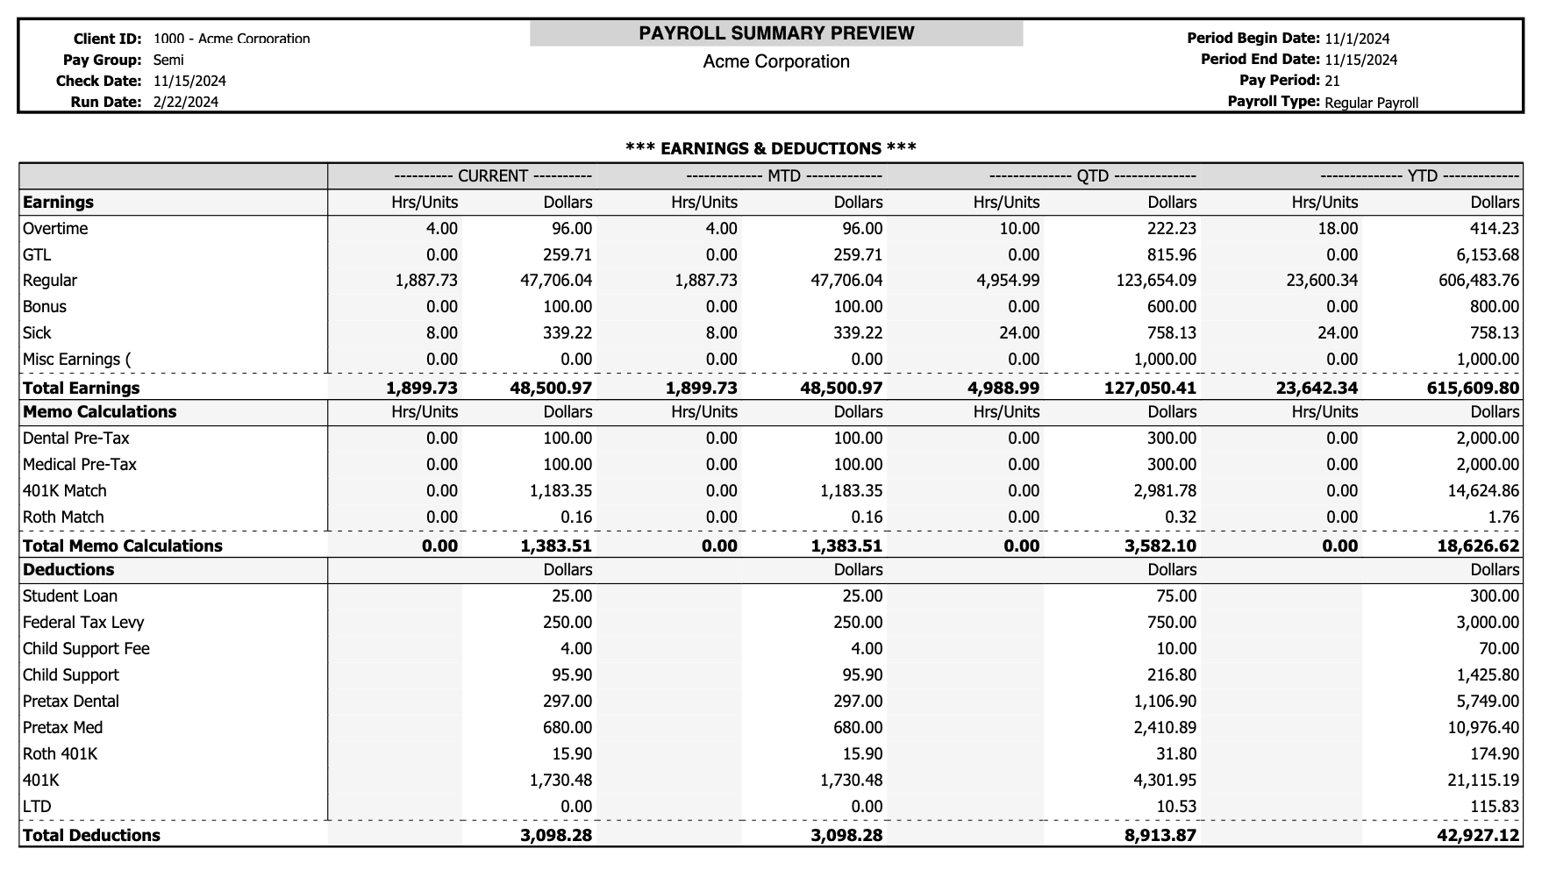

The Payroll Register report breaks down the payroll by employee, showing each employee’s pay (by pay type), deductions, and taxes.

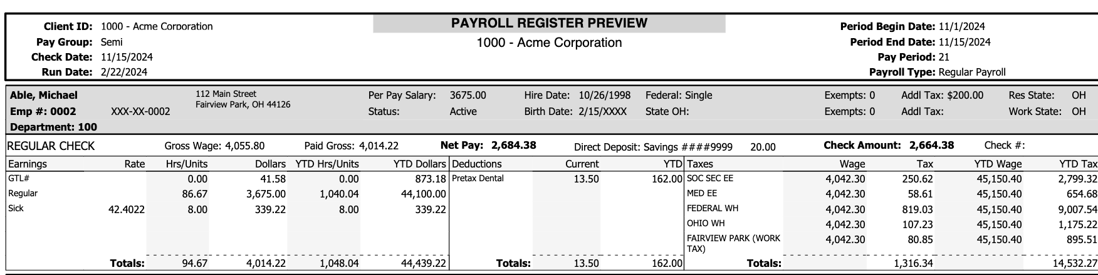

The Payroll Register report also shows company totals and breaks down taxes and deductions totals on separate pages.

Under Next Payroll Run, verify that the dates are correct for the payroll. This date should be for the current payroll.

After you have reviewed the reports for accuracy, click Submit.

Your Payroll Specialist will receive notification that your payroll is ready for processing and will close your payroll.

- Run Payroll Reports

You will receive an email when your payroll has been closed and your reports are available.

You must download or print all reports from the isolved software. Reports will no longer be sent through email by PayPlus due to security concerns, given the highly sophisticated hacking capabilities of thieves. We take your company and employee confidential information very seriously.

